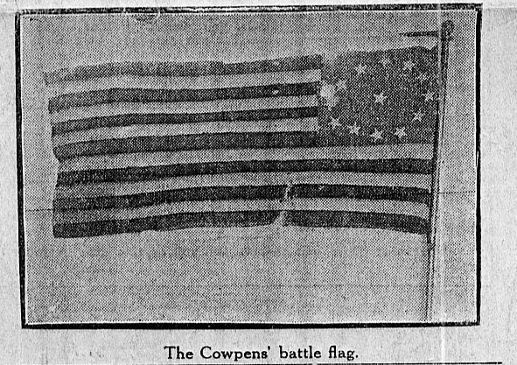

FLAG OF COWPENS. This thirteen-star flag, twelve in a circle with one in the center, was reportedly

carried by Color Sergeant William Batchelor of the Maryland Light Infantry, at the battle of Cowpens, S.C., January 17, 1781. Wounded in the engagement, Batchelor returned with the flag to his Baltimore home; and in the War of 1812 his son, Ensign Joshua F. Batchelor of the 27th Maryland Militia, carried it in the North Point phase of the Battle of Baltimore, September 12, 1814. For years, the younger Batchelor carried the flag on commemorative occasions; but in August, 1843, he deposited it with the Old Defenders' association, a veterans organization formed shortly after the successful defense of Baltimore. On moving to New Jersey, however, he reclaimed the flag and kept it until his death in Newark about 1855. Years later it was returned to Dr. Albert Kimberly Hadel of Baltimore, a member of the Old Defenders group and an officer in its successor organization, the Society of the War of 1812. On October 19, 1907, that group presented it to the State. (58, Reckord, 1965)
The earliest date of record for this flag is 1843. A technical examination provided the following information:
Size: It is approximately 30 inches by 61 inches (width and length vary from one area to another).
Fabric: The union is a blue bunting field of single-ply worsted yarns. Cotton, five-pointed stars are appliquéd to both sides of the flag, twelve in a circle, one in the center. There are thirteen bunting stripes, seven red and six white of single-ply worsted yarns.
Heading: There is none; however, a ropy support with loops at top and bottom are whipped into a bunting hem in place of a heading.
Sewing thread: The 2-ply linen thread was used to stitch bunting. Plied cotton thread was used to stitch stars, and although the number of ply cannot be determined, it is not a cabled thread.
Stitching: It is by hand and with flat-fell seams.
Grommets: There are none.
Date: The cotton stars and the cotton thread used to stitch the stars would date this flag from the nineteenth century rather than the Revolutionary War. There is no reason to doubt that it was in existence in 1843. The flag is very similar to one in the collection of the Division of Military History in the Smithsonian Institution's National Museum of History and Technology, which dates from the period of the Mexican War and is described with the twenty-nine star flags the period in which it was made (Figure 12).
The Smithsonian Institution received two requests for the dating of other flags with twelve stars in a circle and the thirteenth in the center. One, in a private collection in Indiana, was not submitted for examination. The other is described as a hand-stitched thirteen-star flag (see below). It should be noted for comparison.
The Flag of Cowpens, originally deposited with the Old Defender's Association in 1843, may have been a Revolutionary War flag; however, the flag turned over to the state of Maryland in 1907 is not the same flag. The circle of stars with one in the center does not date earlier than the nineteenth century.

