Support The Friends of the
Maryland State Archives

The Friends of the Maryland State Archives is a volunteer organization dedicated to furthering the knowledge and interpretation of Maryland’s rich history. An understanding of our past is important to planning and preparing for our future. Promoting such insight and knowledge, especially through educational and outreach programs for students and teachers, is central to the work of the Friends.

Mission: To further the goals of the Archives in acquiring, preserving and making accessible records, artistic property, and other items relating to the history of Maryland.

yes! I want to support the friends
Name:_________________________________________
Address: ______________________________________
_______________________________________________
Phone:______________
email:_________________________________________

Donation amount: $___________
Please send your tax deductible donation to:
Friends of the Maryland State Archives
3034 Aberdeen Road, Annapolis MD 21403
or donate online at:
msa.md.gov/msa/homepage/html/friends.html

The Friends of the Maryland State Archives is a 501(c)3 organization and donations to it are tax deductible to the full extent of the law.

For more information, contact: Mimi Calver at 410.260.6444 or by email at Mimi.Calver@Maryland.gov
Follow us on Facebook
With thanks to our major donors

Willard Hackerman
The Dorothy L. & Henry A. Rosenberg Foundation
The Middendorf Foundation
Family of Robert N. Gordon
Eddie and Sylvia Brown
Star-Spangled 200
Joseph Ruzicka
Phillip Cantelon
Ross Kimmel
Michael Musick
Shirley C. Brooks
Kathleen Wood
Diana & Brice Clagett
Truman Thomas Semans & Nellie Merrick Semans
Robert L. Oster
Community Foundation for the National Capital Region
Four Rivers Heritage Area
Larry S. & Diana L. Gibson
Christopher & Victoria Allan
Curt L. & Patricia L. Schmoke
Dr. Edward C. & Sallie Papenfuse
Leander McCormick-Goodhart
Bon Secours Health Systems
Judge Levin H. Campbell
Chestertown Library Preservation Foundation Fund
Old Kent Chapter, National Society,
Daughters of the American Revolution
Barbara & Cary Carson
Theresa Baker
Jean Russo, Ph.D.
Rotary Club of Annapolis
The Society of the Cincinnati, Maryland Chapter
The Maryland Society Sons of the American Revolution
The General Society Sons of the Revolution,
Maryland Chapter
Captain John Questers Chapter, Rockville MD
William A. Reese
Edward & Cynthia Shumaker
Dr. Weems McFadden
Orlando Ridout IV
Orlando Ridout V

Thank you for your support

Friends of the
Maryland State
Archives

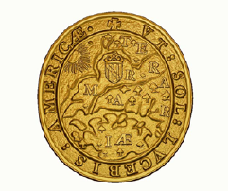

As the sun thou shalt enlighten America

A non-profit group devoted to
supporting the mission of the Maryland State Archives

January 2014
Enrichment of MSA
Special Collections

Donations to the Friends have made it possible for the Archives to add some very important items to its special collections, including:

- George Washington’s personal copy of the speech he gave on December 23, 1783 in the Old Senate Chamber resigning his commission as commander-in-chief of the Continental Army. The Friends are now having a permanent case built for the document to be on display in the rotunda of the State House.
- Letter from Admiral Sir Pulteney Malcolm, captain of the British ship Royal Oak, to his wife describing the British retreat from Baltimore in 1814.
- Two portraits of Leonard Calvert, first governor of Maryland. Gifts included both acquisition and conservation and both paintings are now on display in the State House.
- Memorial to Thurgood Marshall in BWI Thurgood Marshall Airport.
- Early 1800s view of Dartmoor Prison by prisoner J. I. Taylor. This will enhance our research into the soldiers and sailors who were imprisoned there during the War of 1812.
- Mrs. William Barney’s letter to President Andrew Jackson attacking him for his refusal to re-appoint her husband as naval officer for the Port of Baltimore.
- A collection of documents relating to Whitehall, the National Historic Landmark home built in the 1750s by Provincial Governor Horatio Sharpe.
- Letter from Baron Johann de Kalb to George Washington describing a dispute between officers in his Maryland regiment.
- Historically accurate mural for the State House depicting William Barney watching the British fleet from the State House dome. By Frederick artist Richard Schlecht, the mural was a stunning backdrop to the exhibit entitled ‘The enemy nearly all ‘round us’: Annapolis in the War of 1812 in the State House during the 2013 General Assembly session.

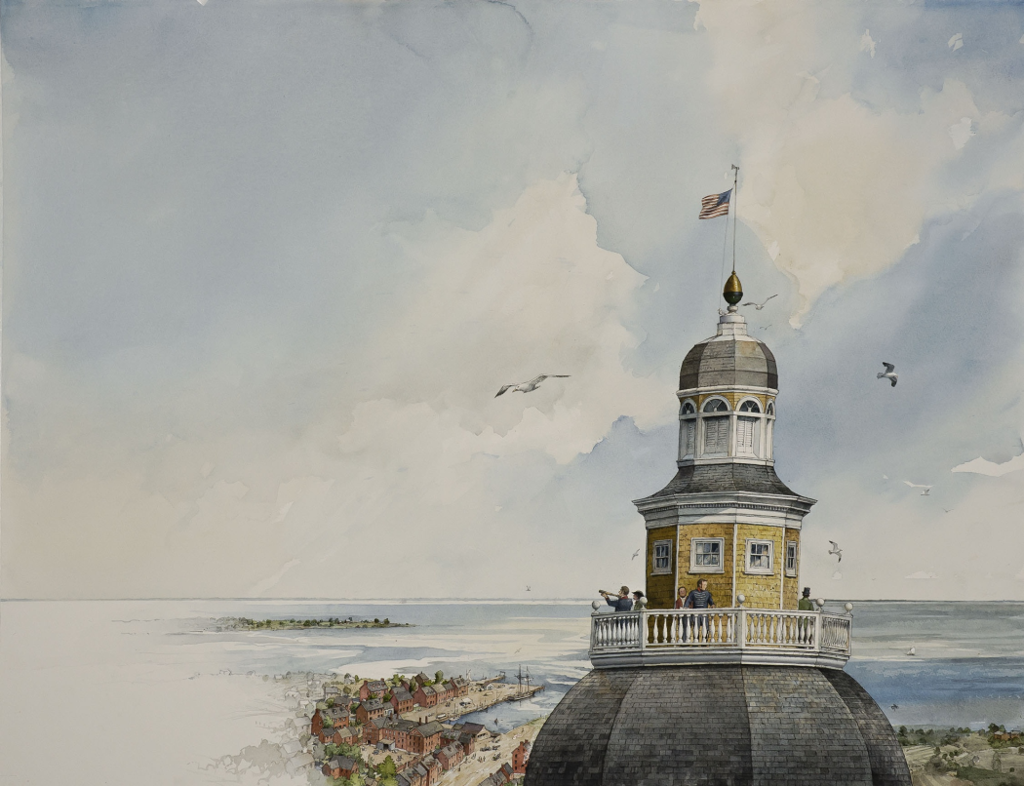

_____________________________

Publications by the Friends of MSA
COMING SOON:

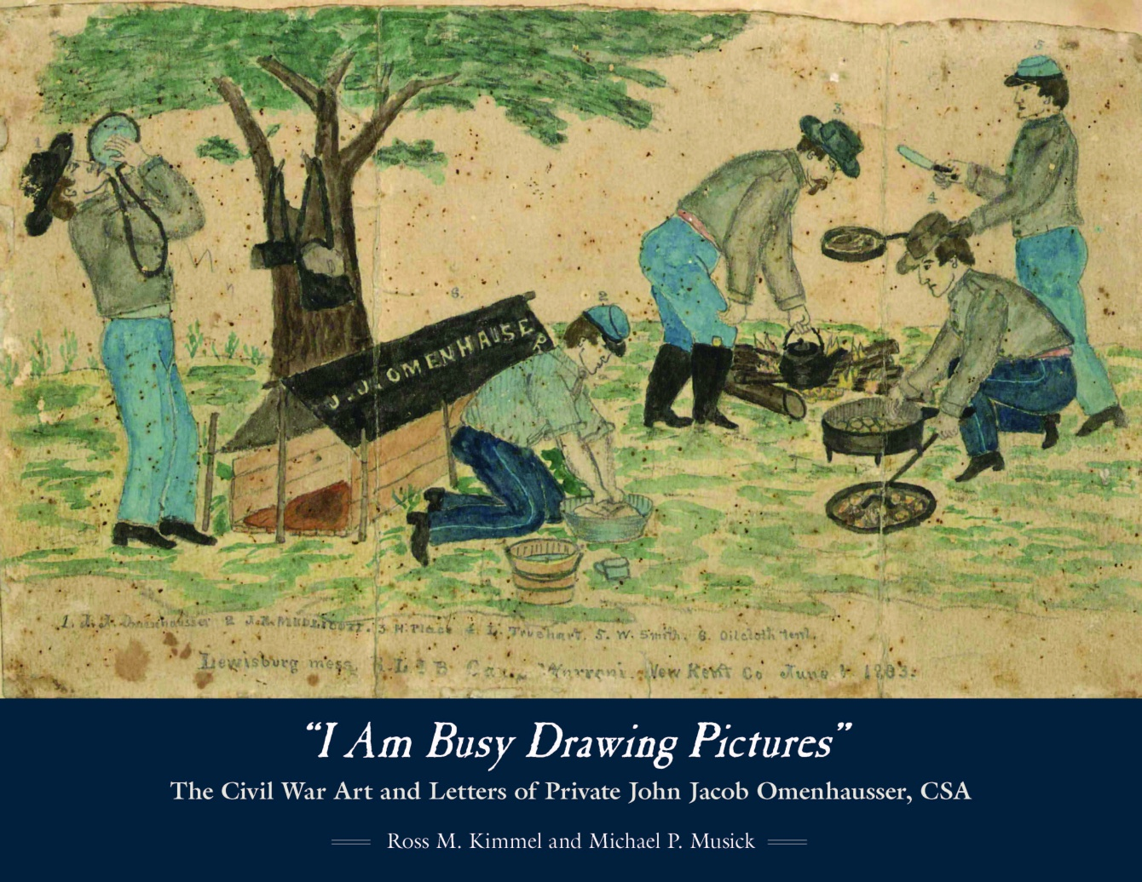

A fascinating look at the Civil War by Baltimore native John Jacob Omenhausser who drew pictures throughout his service in the Confederate Army, including while he was imprisoned at Point Lookout.

Recently Published by the Friends:

BUILDING THE JAMES BRICE HOUSE, 1767-1774
by Orlando Ridout IV

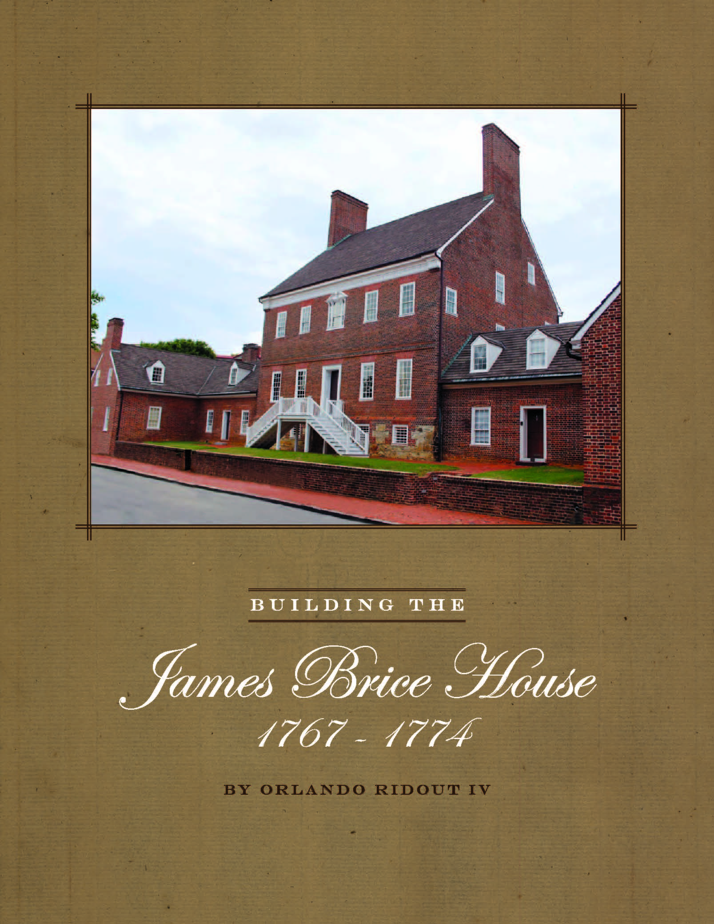

_____________________________

other Friends’ Publications

Maryland’s Art Collection:
A Treasure of paintings, sculpture &
decorative arts

My Unexpected Journey
by Harry Roe Hughes

Lincoln in Annapolis, February 1865
by Rockford E. Toews

While a Tree Grew: The Story of
Maryland’s Wye Oak
by Elaine Rice Bachmann
To order these and other Archives’ publications,
please visit the Archives’ website at mdsa.net

