James Mark Baldwin: Punch lines after all is read
1. Check any legal documents for June 9/10 (Tuesday/Wednesday), 1908, Northwestern Police District at the MDSA. Case of Sidonia (also spelled Sedonia, Sardonia) Young of 501 Tyson Street (or Tyson Alley). [This is 0.3 miles from the Pratt Library!] She was fined 500 dollars (I suspect by Judge Alvin H. Tyson).
Check also case in which Young was found guilty of running a house and served 16 months in jail. Apparently, magistrate in that case v. Young was Judge Stockbridge. Judge Tyson apprised Stockbridge on the character of the man arrested in that case [Baldwin?]. Interestingly, nobody else is mentioned as arrested on June 9/10, 1908!
Note, 501 Tyson Street is marked by Google Maps as a parking area and I am 100% sure this area is where I parked my car when I visited the Pratt Library. Baldwin used to live near where the Pratt Library is now located. It took me 3-5 minutes to walk the distance. Not the place one would imagine a husband would typically go for “illicit” sex as it is so close to his own home!
Any chance there may be old photos of 501 Tyson Street? Need to ask MDSA. Already asked Pratt Library.

2. Magistrate in the case against Baldwin [brought by Young?] was Judge Alvin H. Tyson. Case was evaluated and dismissed. Any documents available at MDSA? Is this in the dockets? I did not see this but I should try again. Judge Tyson felt that, because of the reputation of the man, his identity should be kept secret.

3. Are there any surviving documents of the court case against Captain Ward or was this an internal investigation only (Police Commission) with no surviving document?

December 10, 1909. The Sun, page 12.
When? Raid about 12 months ago (= approx. December 1908). This does *not* fit the time frame for a raid in early summer 1908 but see testimony on in other days.
Where? Tyson Alley (= Tyson Street) Baltimore
Other: “A prominent man was in that raid”… “they (police officers?) got 700 dollars out of him” … [This sounds like a Mexican “mordida” to me.]
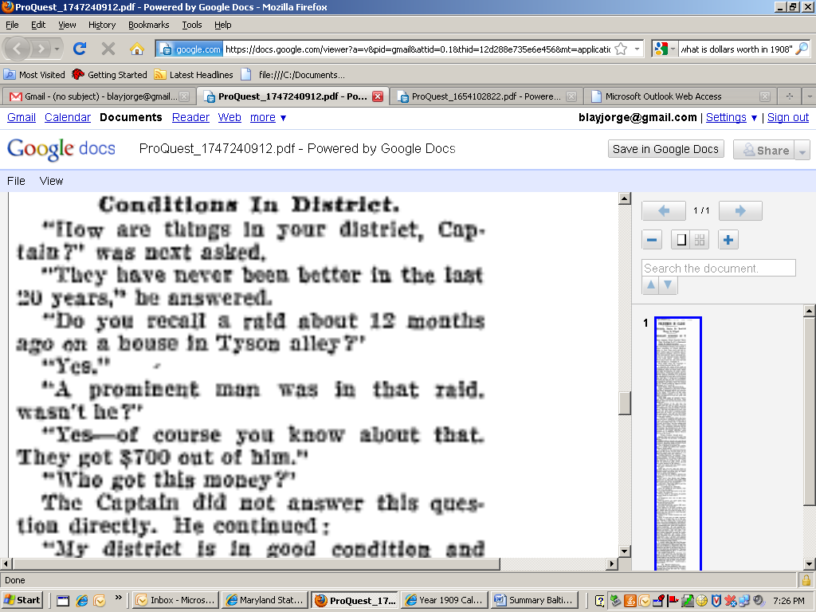
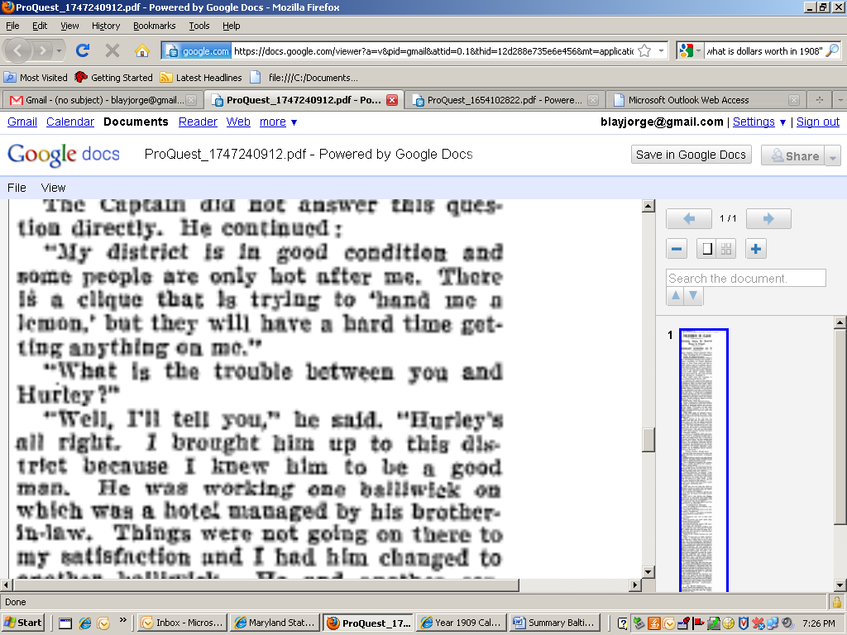

December 11, 1909. The Sun, page 16.
Other: … “a well-known man who was arrested in your [Northwestern] district”… A Justice Tyson told Captain Ward that “some people were holding up this man for money on account of it. … “The man is living abroad … unless the money was paid over the fact that he has been arrested on a house be given publicity and his reputation ruined”… The friend of the unfortunate man said he left this country to escape the demands upon him but that when the proper time arrives he will come forward with testimony he will come forward with testimony to prosecute those who are alleged to have blackmailed him.” …
“Justice Tyson, before who the man was taken after being arrested, said yesterday that after a full consideration of the case he dismissed the charge (what charge?) because there was no foundation for it.”
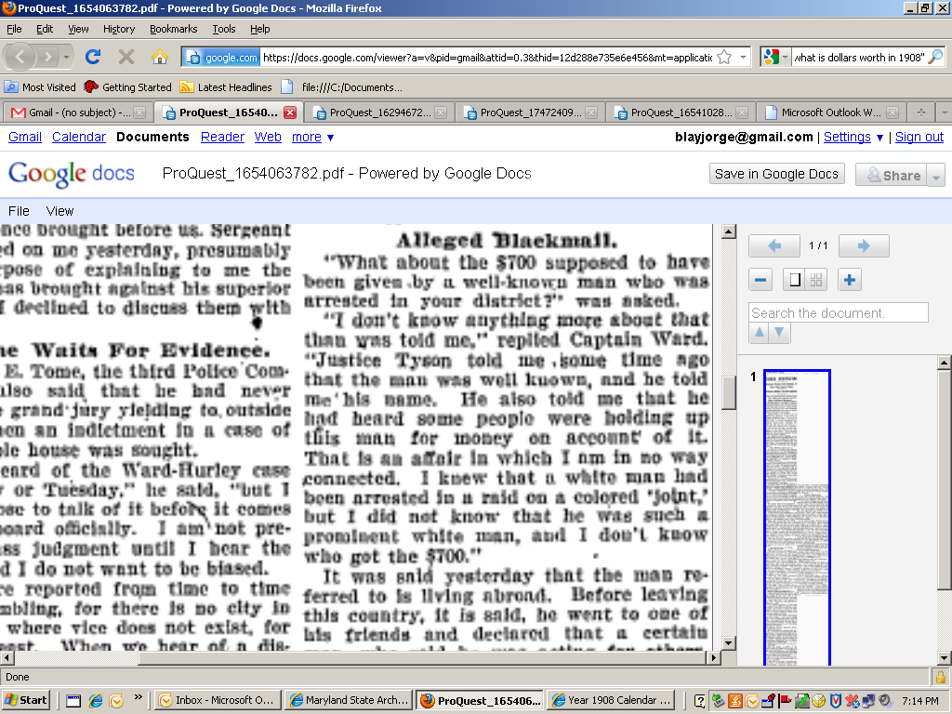
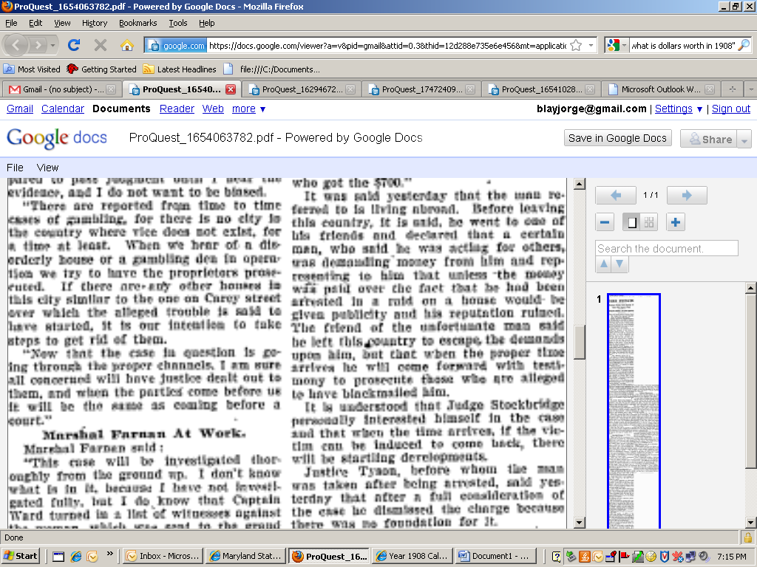

December 16, 1909. The Sun, page14
When: Approximately June 10, 1908.
Other: Sardonia Young charged for keeping a disorderly house, etc. [see definition of “dissorderly house”, http://legal-dictionary.thefreedictionary.com/Disorderly+house , to me, akin to “house of ill repute”]. Patrolman Scrivner transferred to another post about a week after the raid. [Ward running a paid-for-protection ring where everybody benefited as long as it was kept out of the public eye?]
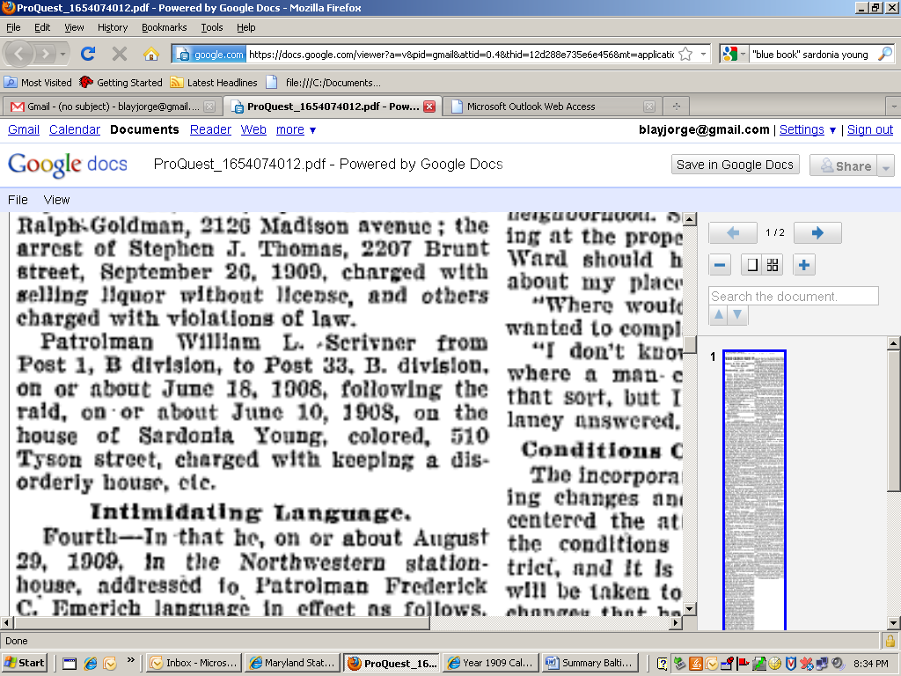

December 18, 1909. The Sun, page 8
Other: Again, Sidonia Young, man went to Europe to evade those chasing him for money.
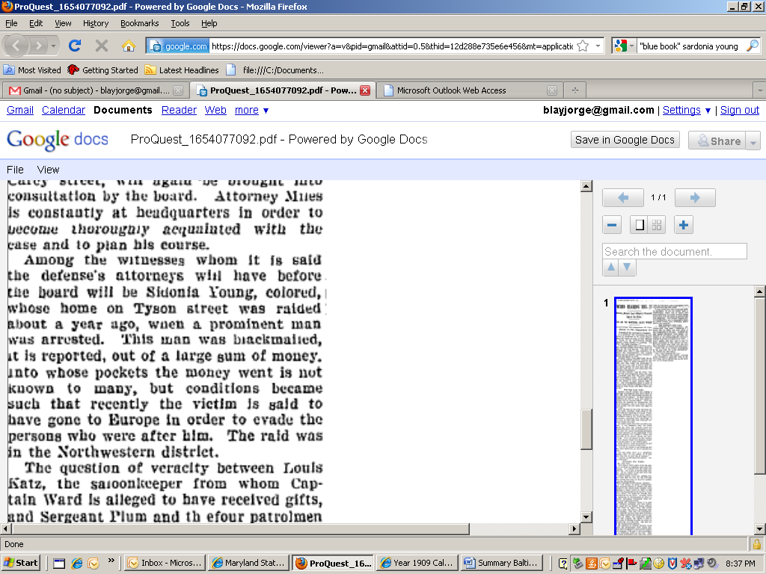

December 24, 1909. The Sun, page 14.
Other: Sargent Plum to be accused of charging for protection of Sidonia Young’s house. A gain, a well-known man paid $700 dollars to get out of the scrape withhis reputation undamaged.
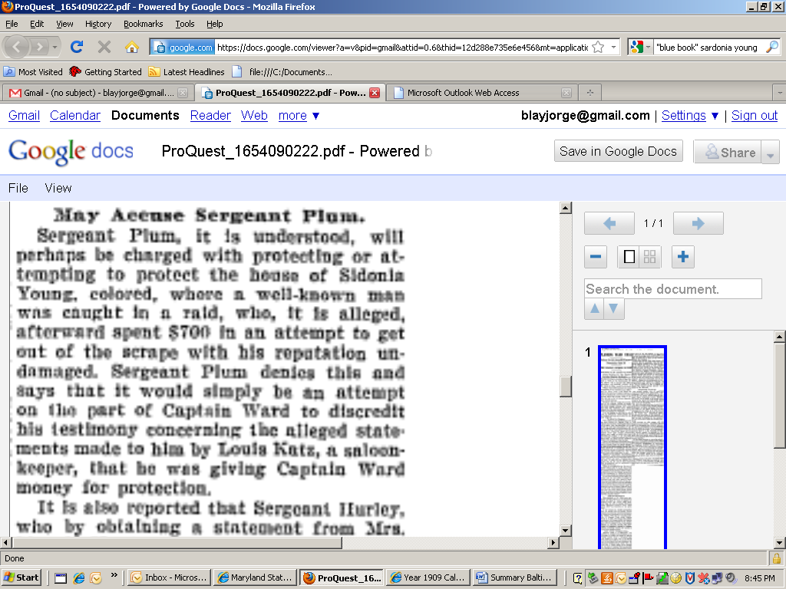
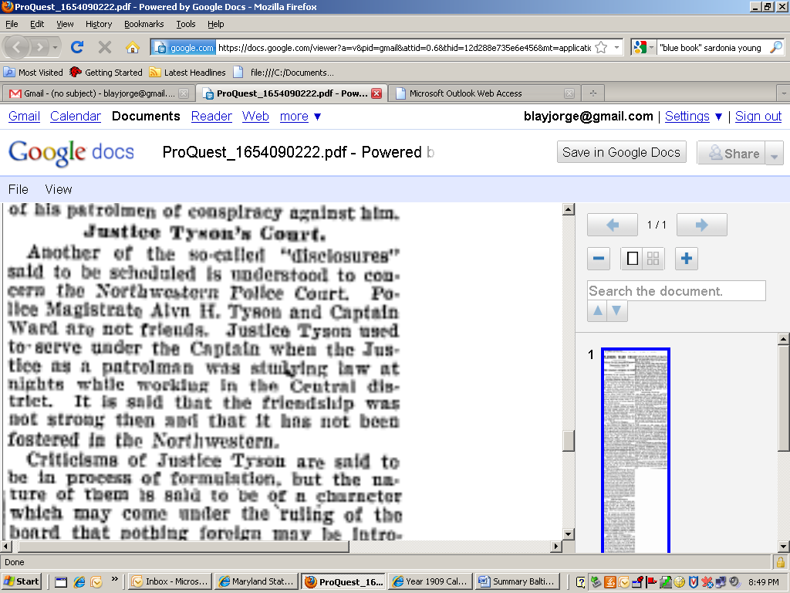
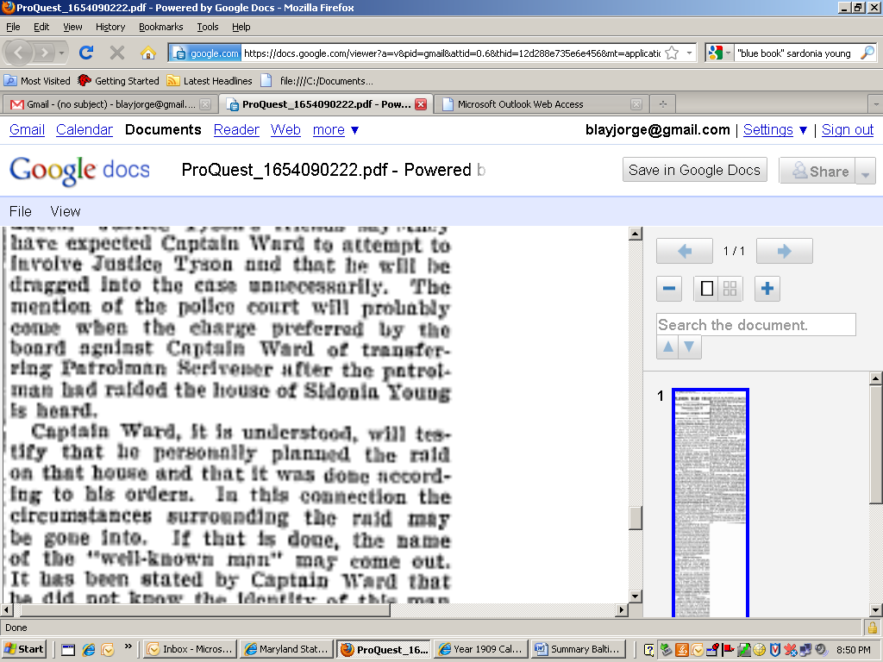
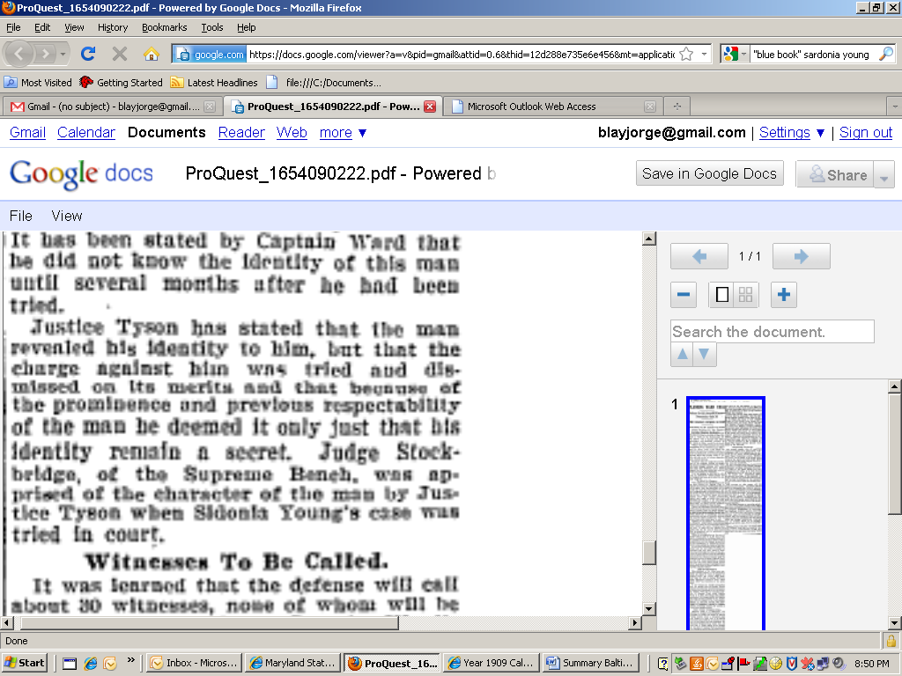

December 27, 1909. The Sun, page 12.
Other: Sedonia Young and other women to testify for Captain Ward, even though they were raided.
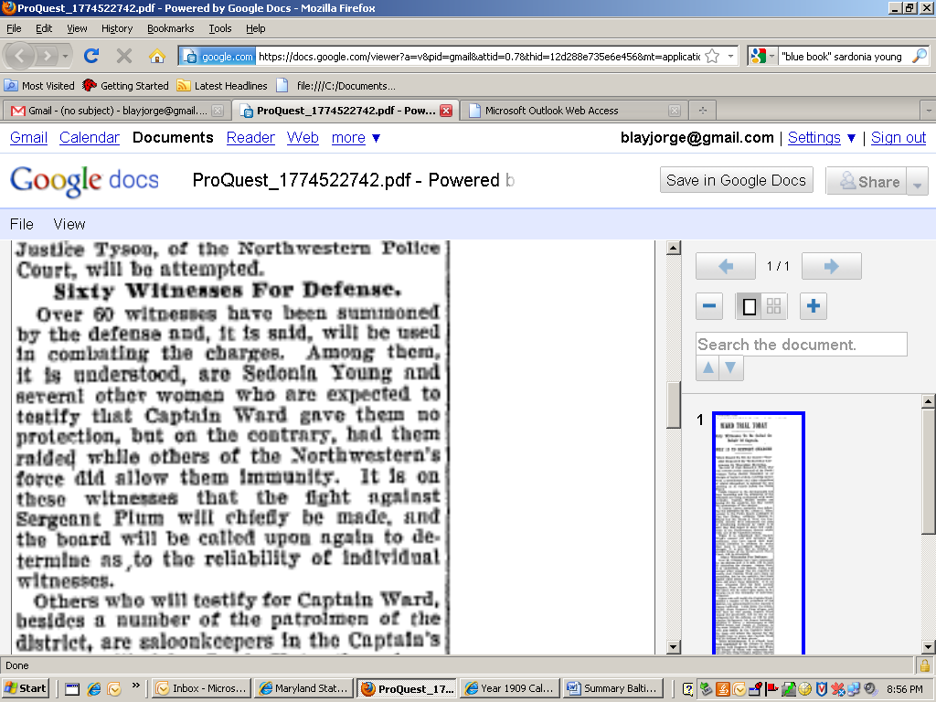

December 29, 1909. The Sun, page 12.
Other: Alleged protection of Sidonia Young by police.
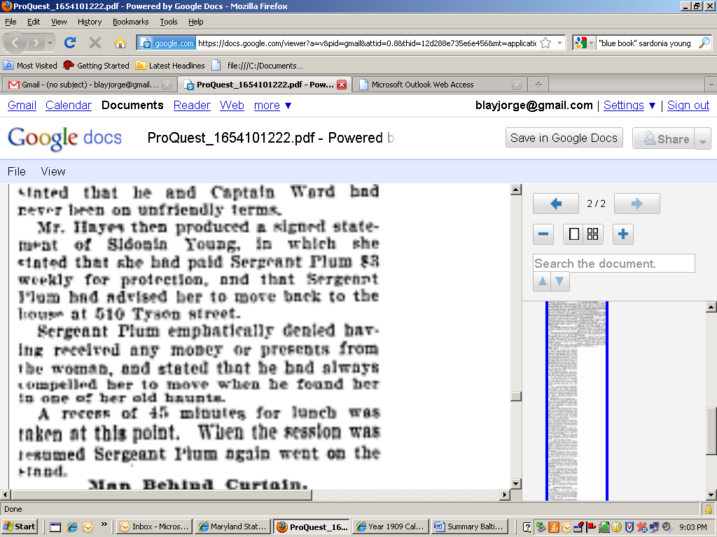

December 30, 1909. The Sun, page 12
Where: At Sidonia Young (“colored”, 510 Tyson Street) house. She was arrested (failed to paid 50 cents out of the 2 dollars protection fee to Officer Scrivner), fined 500 dollars and jailed for 16 months (this puts the original events on June 1908, not on 1909). Officer Scrivner ran for more officers when he saw a white man coming into Sidonia’s house (white man, especially if nicely dressed = potential blackmail money to be made?).
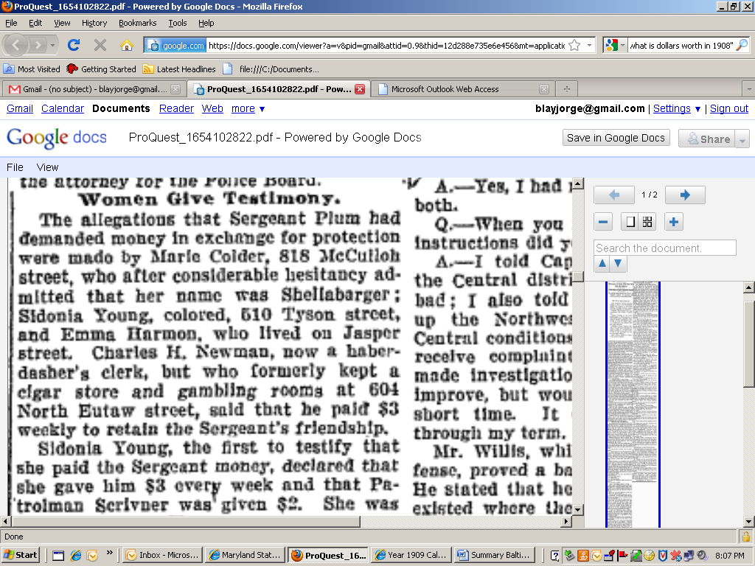
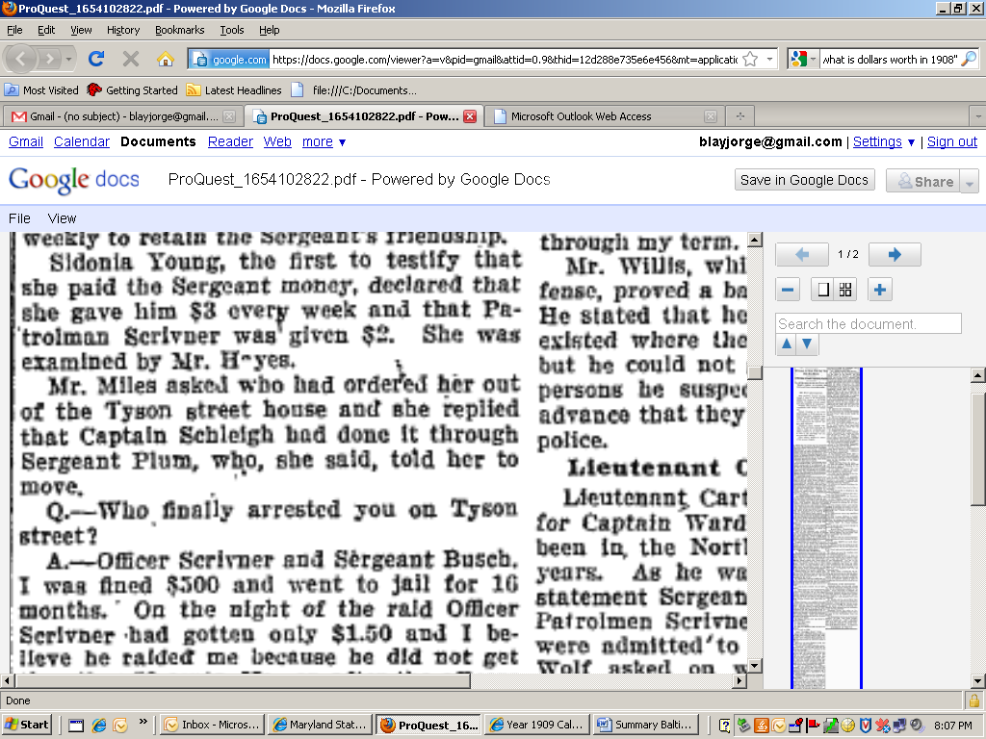
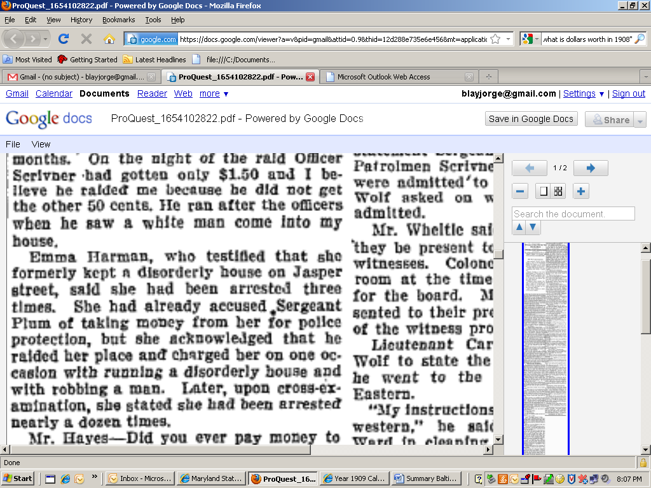

January 2, 1910. The Baltimore Sun, page 12.
Other: Captain Ward dismissed. Three police oficers, including patrolman Serivner but not Captain Ward, directly involved in the arrest at Sidonia Young’s house. Elsewhere Ward has said he gives orders to raid.


