Condition Report Work Sheet

Object #_______

Location: East Courthouse, Courtroom 234, Judge Marcella Holland

Date of examination: 07-15-2004

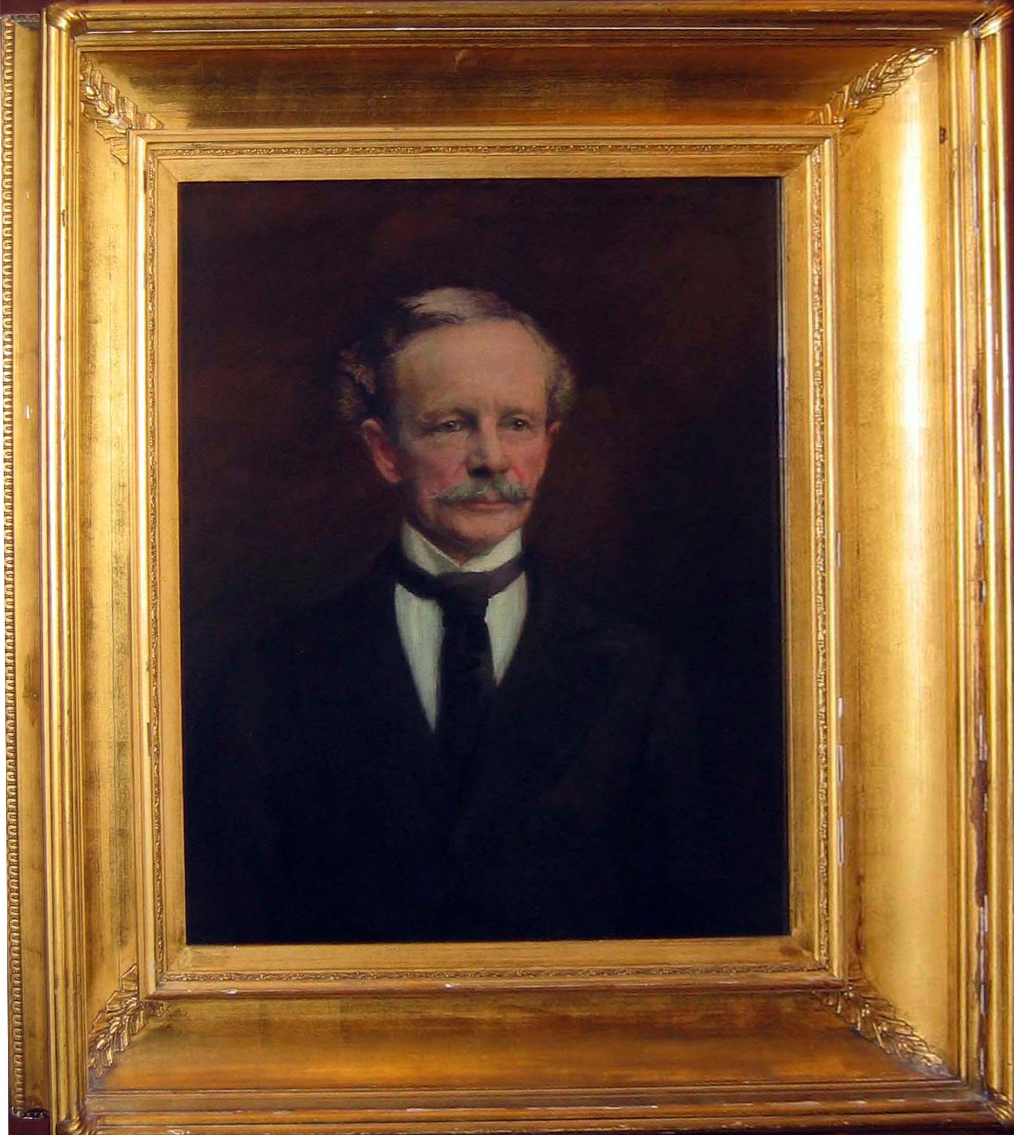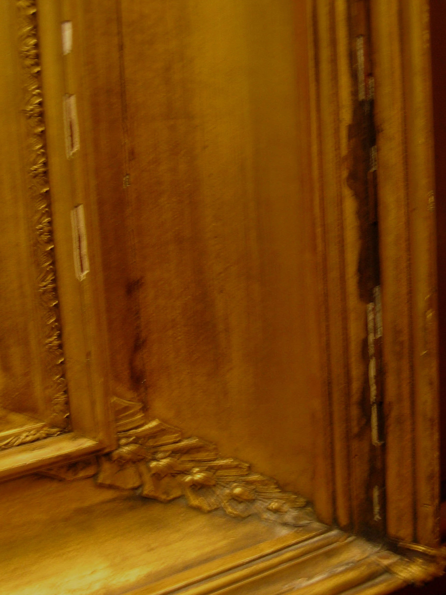

Title/Subject: Chief Judge George William Brown (1812-1890)

Artist: Gabrielle D e Veaux Clements (1858-1948) Date: 1901 Medium: Oil on canvas

Dimensions: Frame: 42 ½ H x 38 W in.

Signature/Date X Yes No, Location: Upper right

Marks/Labels Yes X No, Location:

Description: Portrait of subject.
______________________________________________________________________________________

General Condition:

Painting: Poor Fair X Good / Excellent____

Comments: The painting is in fair condition. There are cracks starting to spider around the face of the subject, especially below the eyes. Although, “cracking” does occur over time in paintings, it seems a bit excessive in this particular piece.

Frame: Poor / Fair X Good Excellent____

Comments: There is a glazing over the painting. The frame is in fair-poor condition. There are cracks, chips, and discoloration of the “gilding” all around the frame and the decorative leafs. Note there is a “crack” that goes all the way around the inner portion of the frame. The frame consists of several pieces combined to form a larger frame, however the crack is excessive.

Conservation Priority: Low Medium X High _____

Comments: Consult a conservator about the cracking in the area of the face (this may be just be typical with the aging of the painting and canvas) and the condition of the frame.

Additional Comments:
Condition Report Work Sheet

Object #_______

Location: East Courthouse, Courtroom 234

Date of examination: 07-15-2004

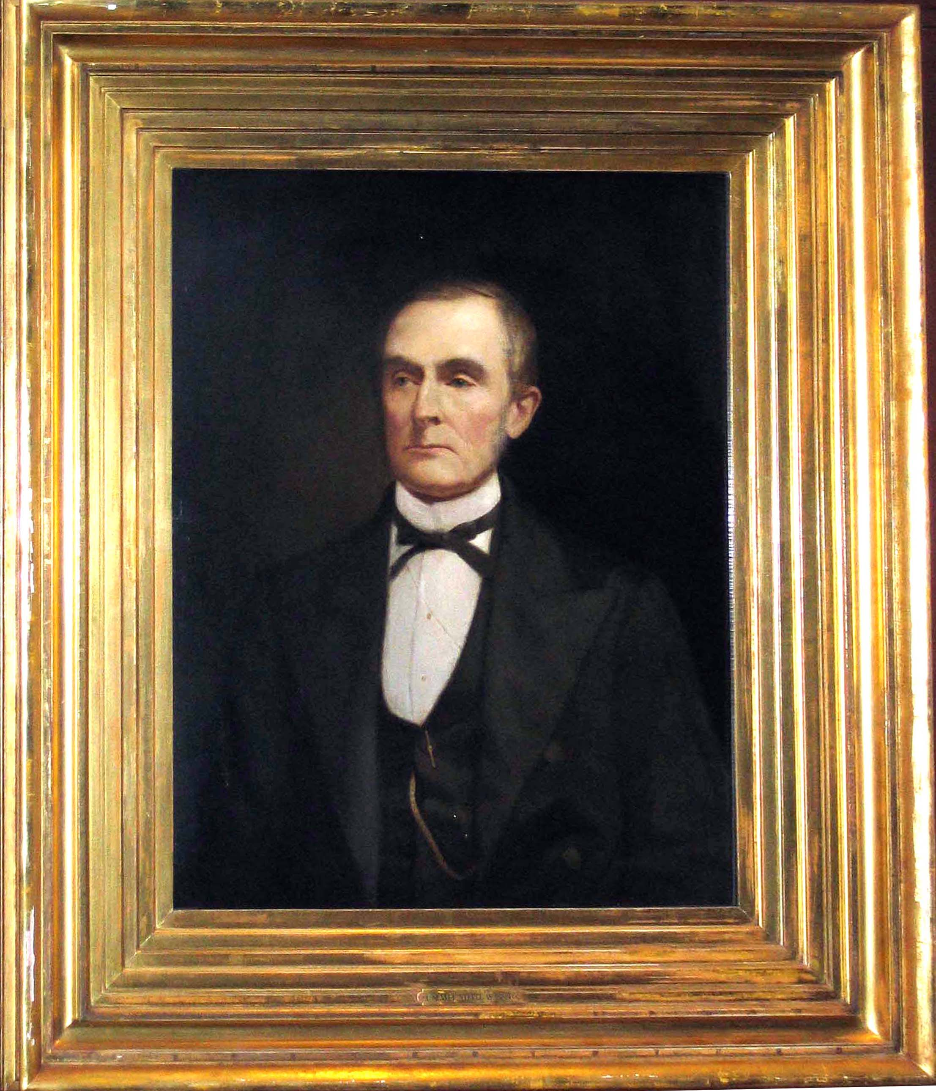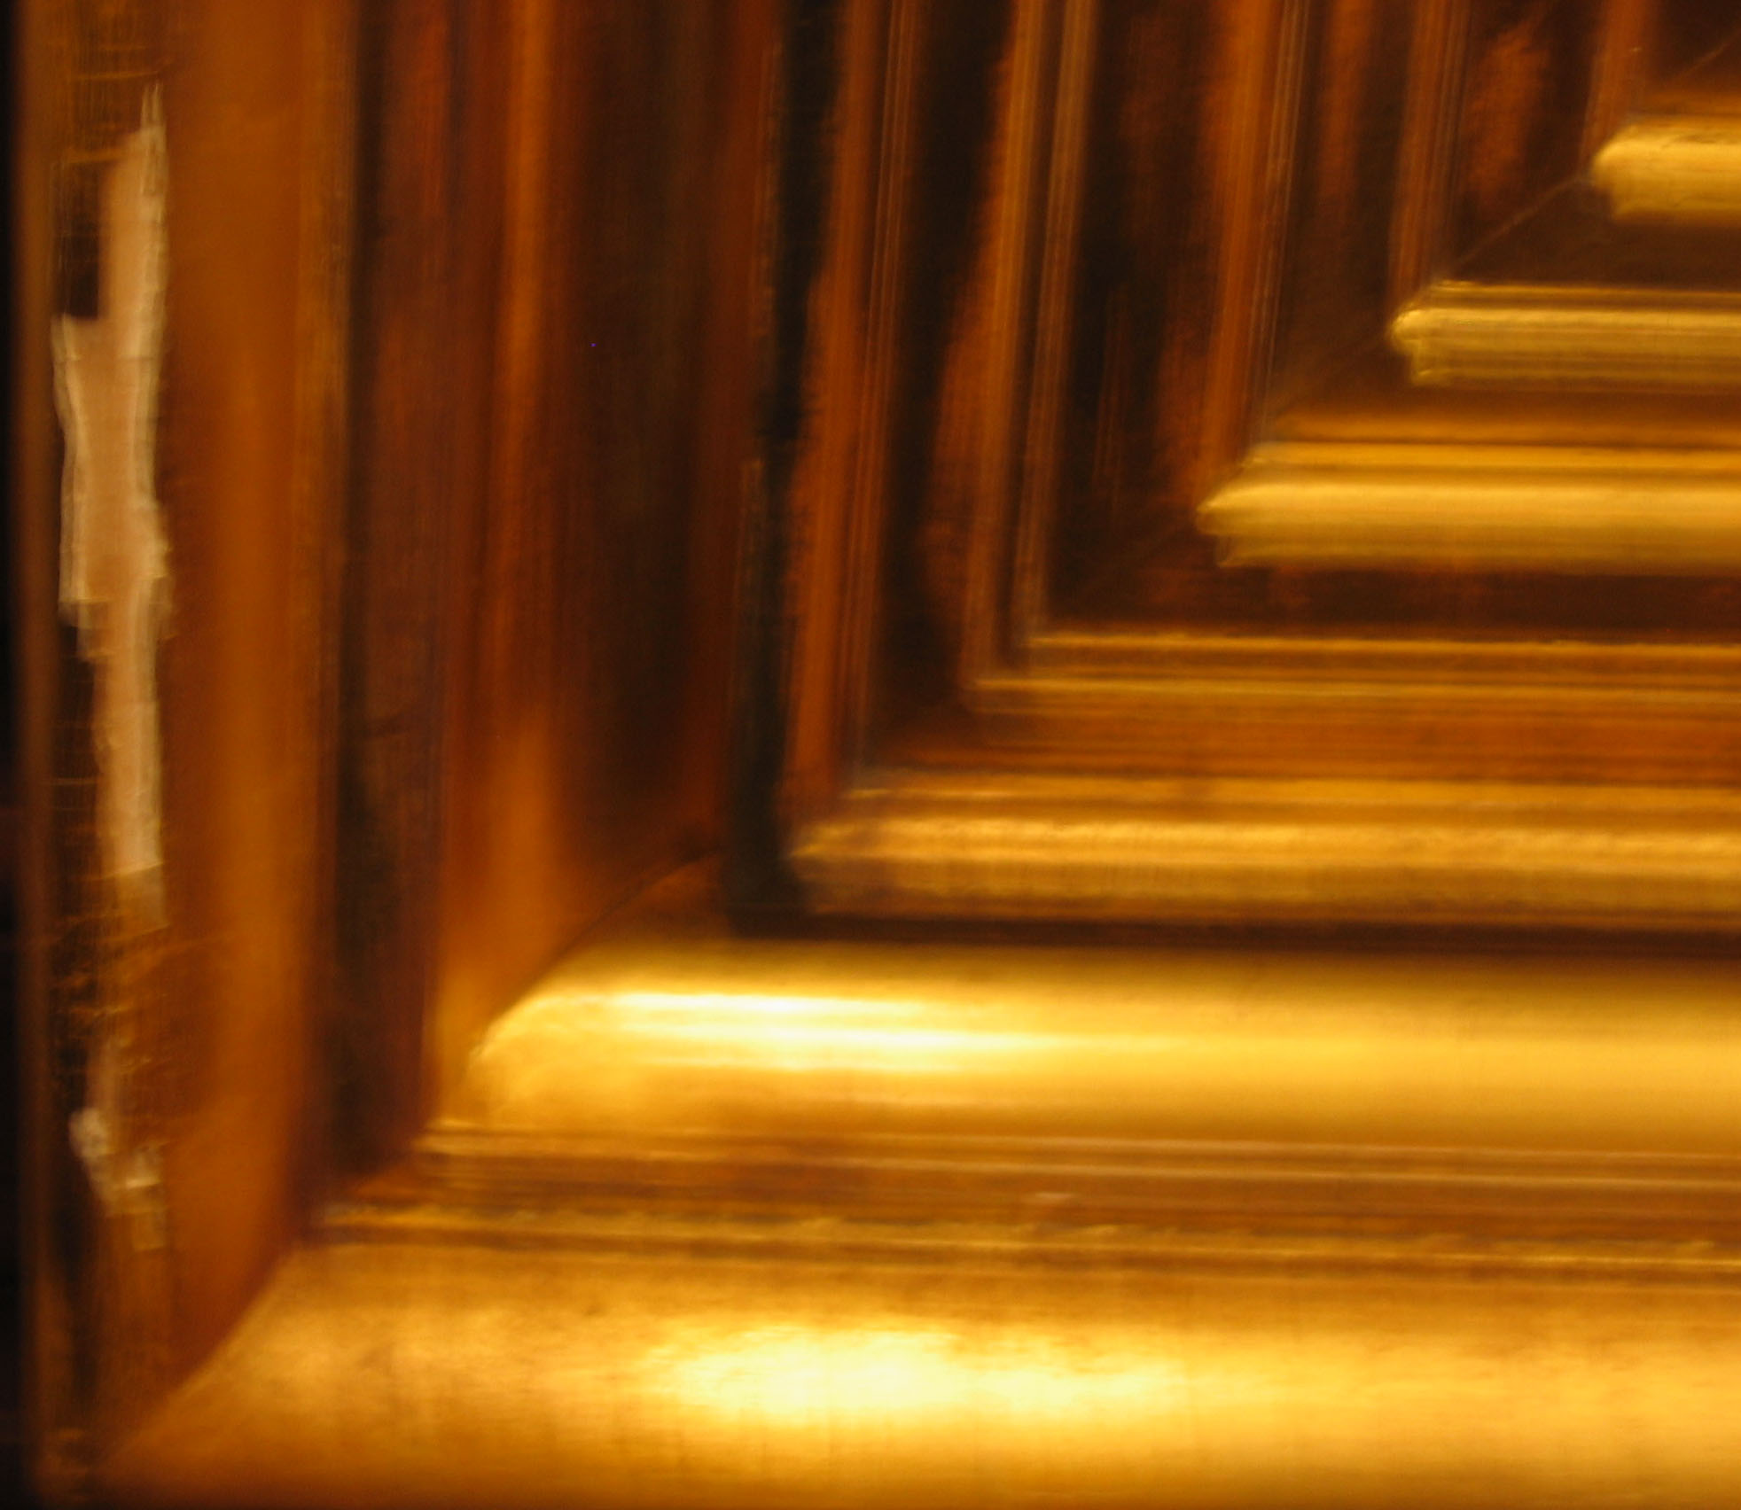

Title/Subject: I. Nevitt Steele 1809-1891 Artist: Clinton Peters (1865-1948) Date: 1900

Medium: Oil on canvas

Dimensions: Frame: 55 H x 46 W in.

Signature/Date X Yes No, Location: Upper left

Marks/Labels X Yes No, Location: Bottom center

Description: Portrait of subject. The plaque reads: I. Nevitt Steele 1809-1891

______________________________________________________________________________________

General Condition:

Painting: Poor / Fair X Good Excellent____

Comments: The painting is in fair-poor condition. There appears to be signs of buckling and warping in the upper right portion of the canvas primarily near the face of the subject.

Frame: Poor / Fair X Good Excellent____

Comments: There is a glazing over the painting. The frame is in fair-poor condition. There are cracks, chips, and discoloration of the “gilding” throughout the frame.

Conservation Priority: Low Medium X High _____

Comments: Consult a conservator about buckling/warping area in the upper right near the face of the subject.

Additional Comments:

Condition Report Work Sheet

Object #_______

Location: East Courthouse: Courtroom 330

Date of examination: 07-09-2004

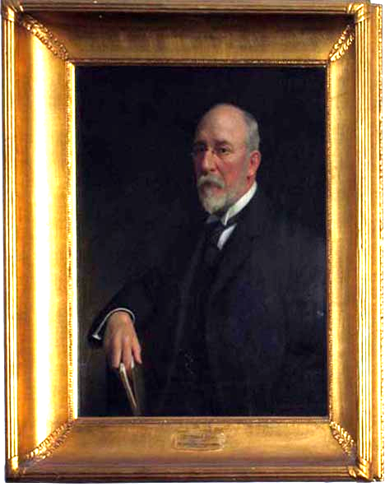

Title/subject: Thomas S. Baer 1843-1906 Artist: Thomas C. Corner (1865-1938) Date: 1908

Medium: Oil on canvas

Dimensions: Frame: 44 H x 38 ½ W in.

Signature/Date X Yes No, Location: Lower right

Marks/Labels Yes No, Location: Bottom center

Description: Plaque reads: Thomas S. Bear 1843-1906, Associate Judge of the Supreme Bench of Baltimore City.

General Condition:

Painting: Poor Fair Good X Excellent____

Comments: The painting is in good condition and there are no major concerns or conservation issues.

Frame: Poor____ Fair____ Good X Excellent____

Comments: There is a glazing over the painting. The frame is in good condition. However, there are only a few chips throughout the frame.

Conservation Priority: Low X Medium High _____

Comments:

Additional Comments:

Condition Report Work Sheet

Object #_______

Location: East Courthouse: Courtroom 330

Date of examination: 07-09-2004

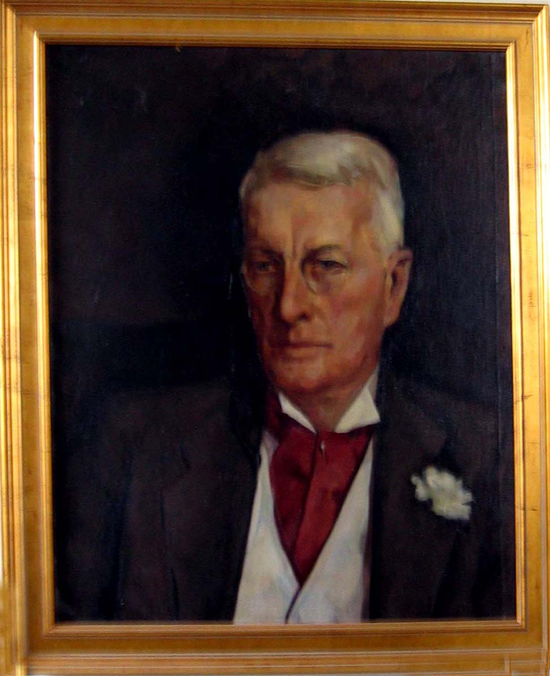 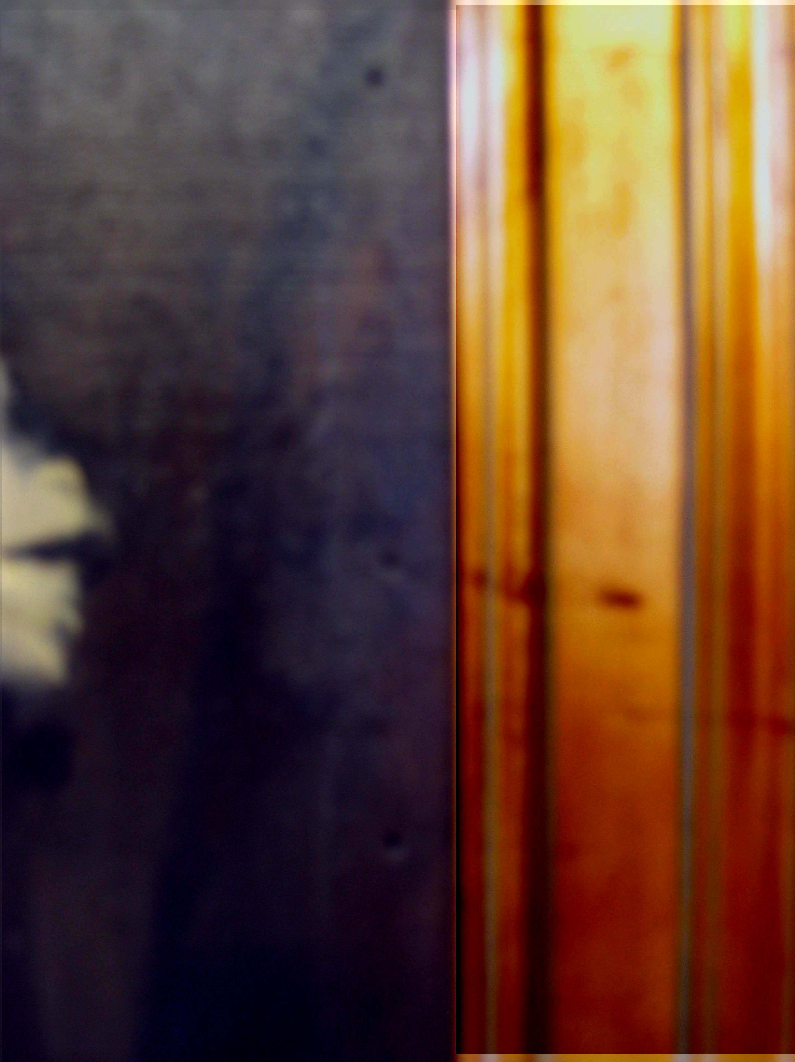 Note the small holes RT side of canvas.

Title/Subject: Judge Eugene O’Dunne (1875-1959) Artist: Unknown Date: Unknown

Medium: Oil on canvas

Dimensions: Frame: 28 ½ H x 25 W in.

Signature/Date Yes X No, Location:

Marks/Labels Yes X No, Location:

Description: A portrait of Judge Eugene O’Dunne

General Condition:

Painting: Poor Fair / Good X Excellent____

Comments: The painting is in fair-good condition. Note there are 12 small holes punched along the entire right side of the canvas next to the frame.

Frame: Poor____ Fair____ Good X Excellent____

Comments: The frame is in good condition. There are no major issues or conservation concerns. There is some discoloration/fading of the gilding on the frame.

Conservation Priority: Low X Medium High _____

Comments: Watch the exposure of direct sunlight on the left side of the painting.

Additional Comments:
Condition Report Work Sheet
Object #_______

Location: East Courthouse: Courtroom 330

Date of examination: 07-09-2004

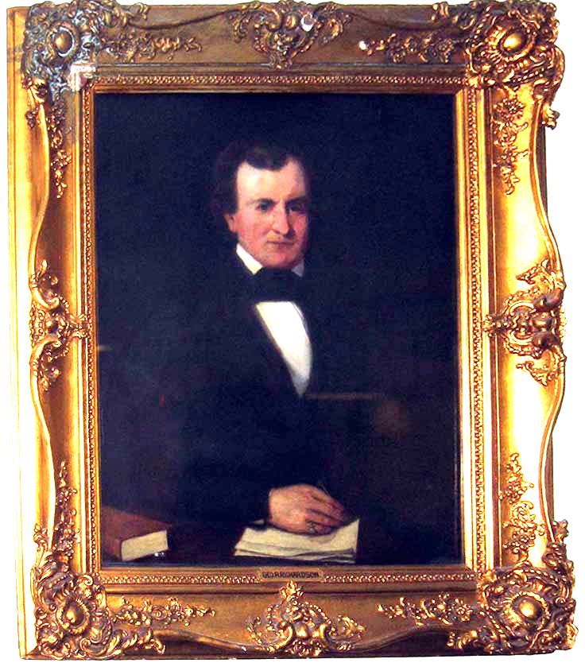

Title/Subject: George R. Richardson (1803-1851) Artist: Unknown Date: Unknown

Medium: Oil on canvas

Dimensions: Frame: 48 ½ H x 42 ½ W in.

Signature/Date Yes X No, Location:

Marks/Labels X Yes No, Location: Bottom center

Description: Plaque reads Geo. R. Richardson.

General Condition:

Painting: Poor Fair / Good X Excellent____

Comments: The painting is in fair to good condition. There also appears to be a small tear or bulking in the upper left corner of the canvas.

Frame: Poor____ Fair X Good Excellent____

Comments: There is a glazing over the painting. There appears to be mold or serious discoloration in the upper left corner of the frame. There are medium sized chips in the upper decorative leaf and center top of the frame. If there is mold in the frame seriously consider replacing the frame.

Conservation Priority: Low X Medium X High _____

Comments: Consider moving painting off of the exterior wall and placing cork at the bottom corners of the frame to create more distance between the wall and especially the frame.

Additional Comments: Consider retightening the keys on the frame to stretch the canvas to its proper size. Consider this piece to be viewed by a conservator.

Condition Report Work Sheet

Object #_______

Location: East Courthouse: Courtroom 330

Date of examination: 07-09-2004

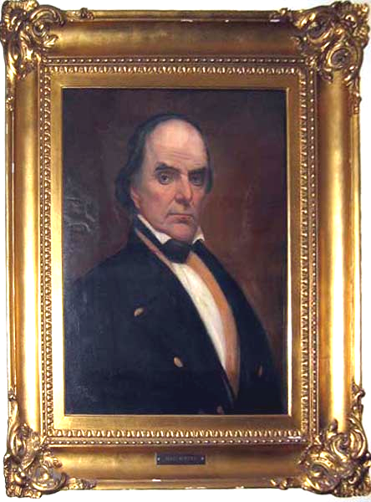

Title/Subject: Daniel Webster (1762-1852) Artist: Unknown Date: Unknown

Medium: Oil on canvas

Dimensions: Frame: 38 H x 34 W in.

Signature/Date Yes X No, Location:

Marks/Labels X Yes No, Location: Bottom center

Description: Plaque reads Daniel Webster

General Condition:

Painting: Poor Fair X Good / Excellent____

Comments: The painting is in fair-good condition. There appears to be some signs of bulking/warping in the canvas.

Frame: Poor____ Fair X Good Excellent____

Comments: There is a glazing over the painting. There are chips on the majority of the bottom portion of the frame and the left side.

Conservation Priority: Low X Medium / High _____

Comments: Consider moving the painting from the exterior wall. It looks as if there are some signs of warping/bulking in the canvas, which is probably due to environmental issues stress of being hung on an exterior wall. Also consider retightening the keys on the frame to stretch the canvas to its proper size.

Additional Comments:

Condition Report Work Sheet

Object #_______

Location: East Courthouse Courtroom 528

Date of examination: 07-19-2004

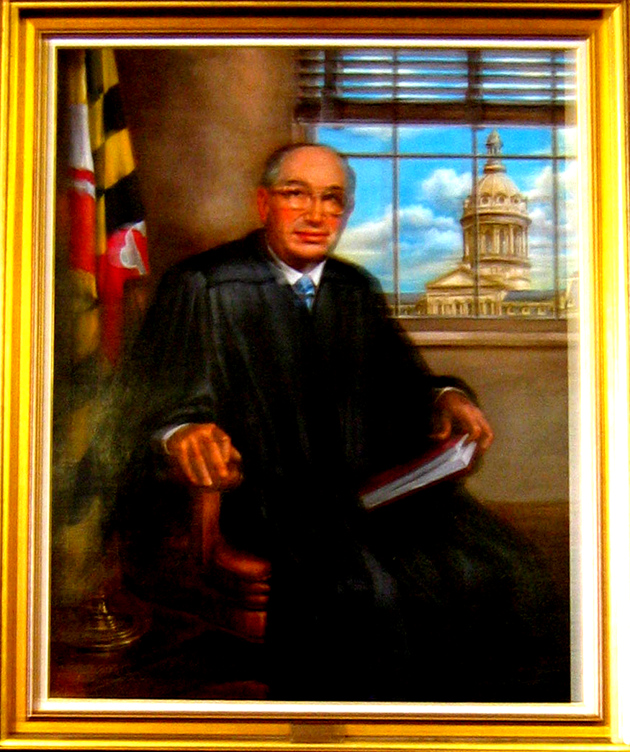

Title/Subject: Judge Joseph Sherbow (1901-1979) Artist: Dr .Emanuel Glasser: Date: 1982

Medium: Oil on canvas

Dimensions: Frame: 58 H x 48 W in.

Signature/Date X Yes No, Location: Lower right

Marks/Labels X Yes No, Location: Bottom center

Description: A portrait of the subject sitting down. Plaque reads Joseph Sherbow 1901-1979 Associate Judge of Supreme Bench 1944-1952, presented by family 1982

______________________________________________________________________________________

General Condition:

Painting: Poor Fair Good X Excellent______

Comments: The painting is in good condition and there no major issues or conservation concerns.

Frame: Poor Fair Good X Excellent______

Comments: The frame is in good condition. There is a chip on the lower right outside portion of the frame.

Conservation Priority: Low X Medium High _____

Comments:

Additional Comments:

Condition Report Work Sheet

Object #_______

Location: East Courthouse: Courtroom 540

Date of examination: 07-09-2004

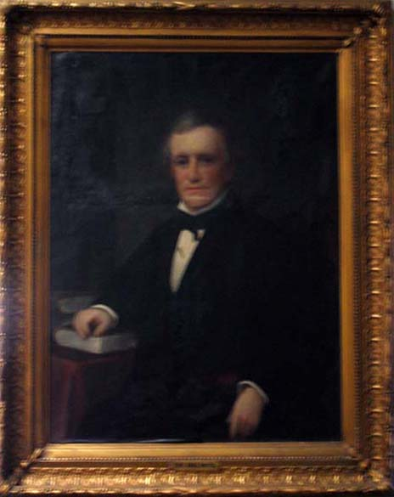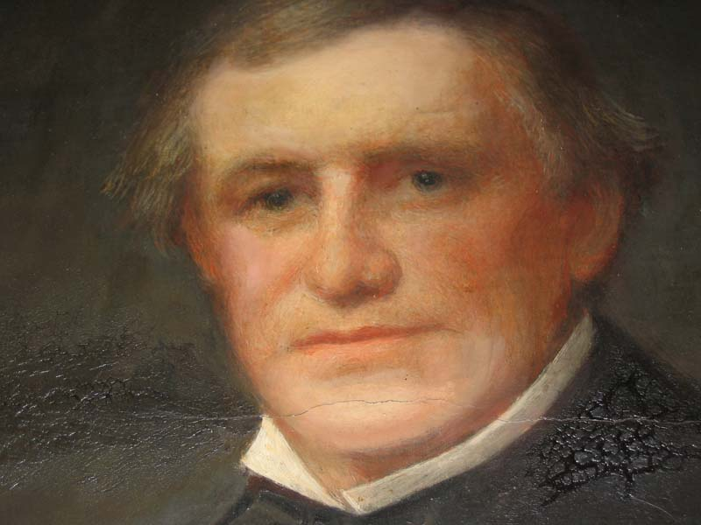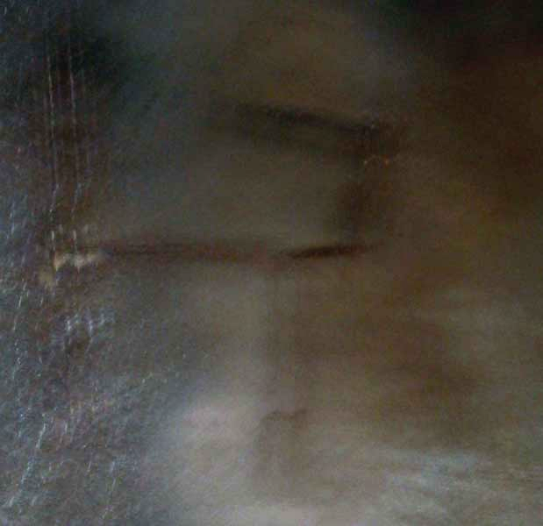

Title/Subject: Chief Judge James Bartol (1813-1887) Artist: Unknown Date: Unknown

Medium: Oil on canvas

Dimensions: Frame: 49 H x 42 W in.

Signature/Date Yes X No, Location:

Marks/Labels X Yes No, Location: Bottom center

Description: Plaque reads Chief Judge Bartol

General Condition:

Painting: Poor / Fair X Good Excellent____

Comments: The painting is in poor-fair condition. There is a medium size tear/splitting of the canvas in the upper left corner of the canvas and there are cracks around the face of Judge Bartol.

Frame: Poor____ Fair / Good X Excellent____

Comments: The frame is in good- fair condition with a few nicks and chips throughout. The molding of the frame is exposed in the lower left portion of the canvas.

Conservation Priority: Low Medium X High __/___

Additional Comments: Have a conservator look at this piece. Fix the “rabbett felt” in order to protect the painted canvas from any abrasion from the rough inside edges of the frame. Consider moving off of the exterior wall due to fluctuation of humidity and temperature control issues. Also consider glazing the piece.

Condition Report Work Sheet

Object #_______

Location: East Courthouse: Courtroom 540

Date of examination: 07-09-2004

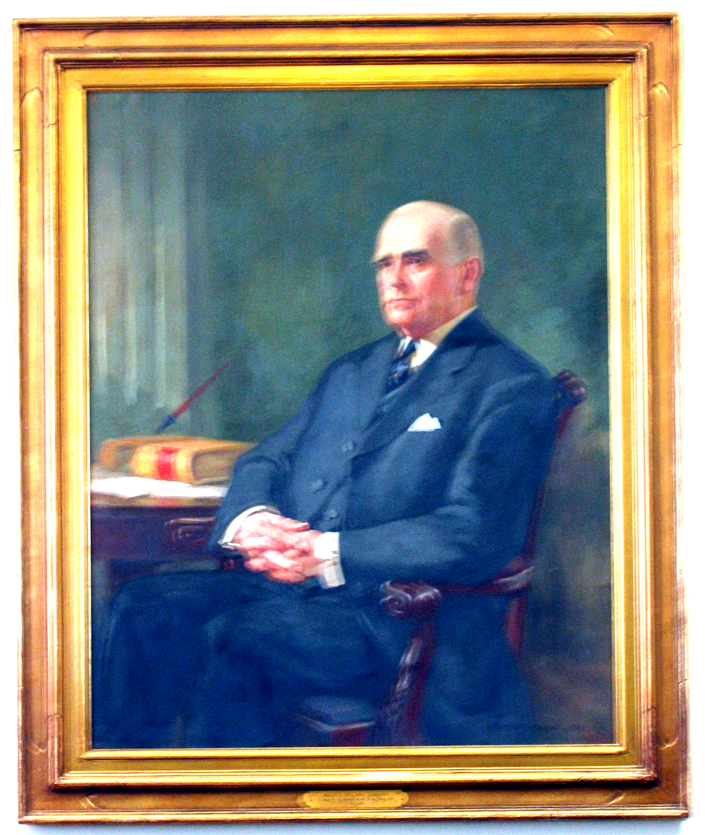

Title/Subject: Walter Ireland Dawkins (1858-1936) Artist R. McGIll Mackall: (1889-1982) Date: 1939

Medium: Oil on canvas

Dimensions: Frame: 56-58 H x 50 W in.

Signature/Date X Yes No, Location: Lower right

Marks/Labels X Yes No, Location: Bottom center

Description: Plaque reads Walter Ireland Dawkins, A judge of the Supreme Bench of Baltimore City 1911-1934. Old marking Right side II, Left side 200.

General Condition:

Painting: Poor Fair Good X Excellent____

Comments: The painting is in good condition, and there are only a few minor spots on the lower right corner of the canvas.

Frame: Poor____ Fair____ Good X Excellent____

Comments: The frame is in good condition. There are a few chip and nicks here and there on the frame. There is also some fading of the “gold leaf” paint mainly on the bottom portion of the frame.

Conservation Priority: Low X Medium High _____

Additional Comments:

Condition Report Work Sheet

Object #_______

Location: East Courthouse: Courtroom 540

Date of examination: 07-09-2004

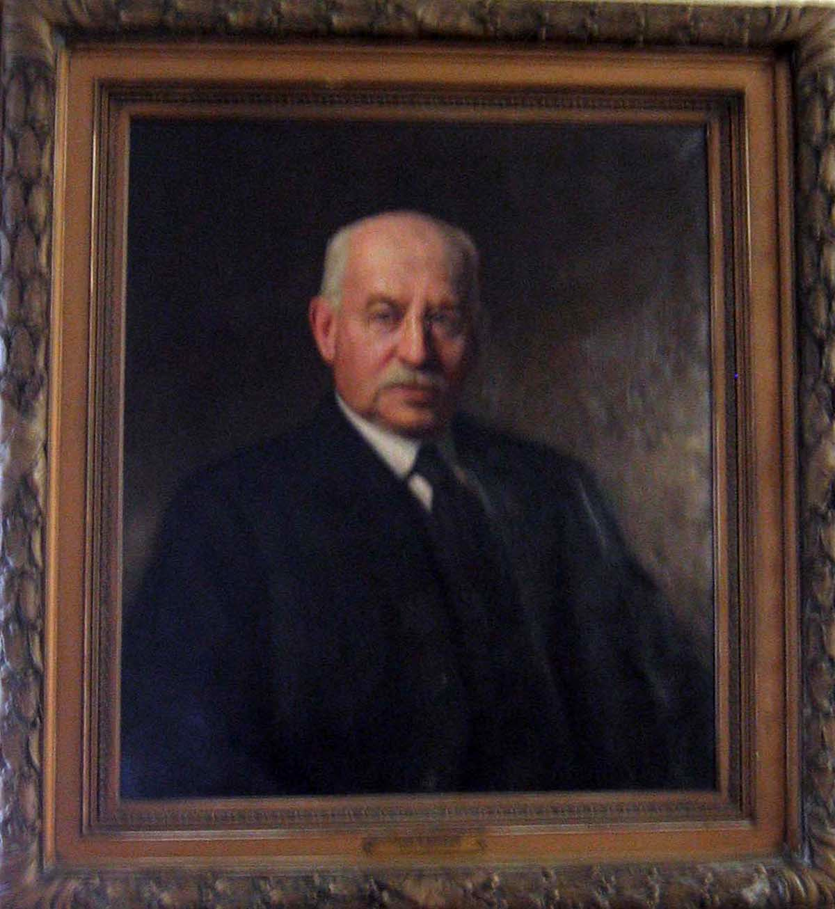

Title/subject: John J. Dobler (1853-1923) Artist: Thomas C. Corner (1865-1938) Date: 1923

Medium: Oil on canvas

Dimensions: Frame: 43 H x 37 ½ W in.

Signature/Date X Yes No, Location: Lower right

Marks/Labels X Yes No, Location: Center bottom

Description: Plaque reads: 1894-1922

General Condition:

Painting: Poor Fair Good X Excellent____

Comments: The painting is in good condition and there no major issues or conservation concerns.

Frame: Poor____ Fair Good X Excellent____

Comments: The frame is in fair to good condition. There are chips and small cracks throughout the frame and the decorative leaf. The inner portion and top center of the frame has chips.

Conservation Priority: Low X Medium High _____

Comments:

Additional Comments: Consider moving the painting from the exterior wall.

Condition Report Work Sheet

Object #_______

Location: East Courthouse: Courtroom 540

Date of examination: 07—09-2004

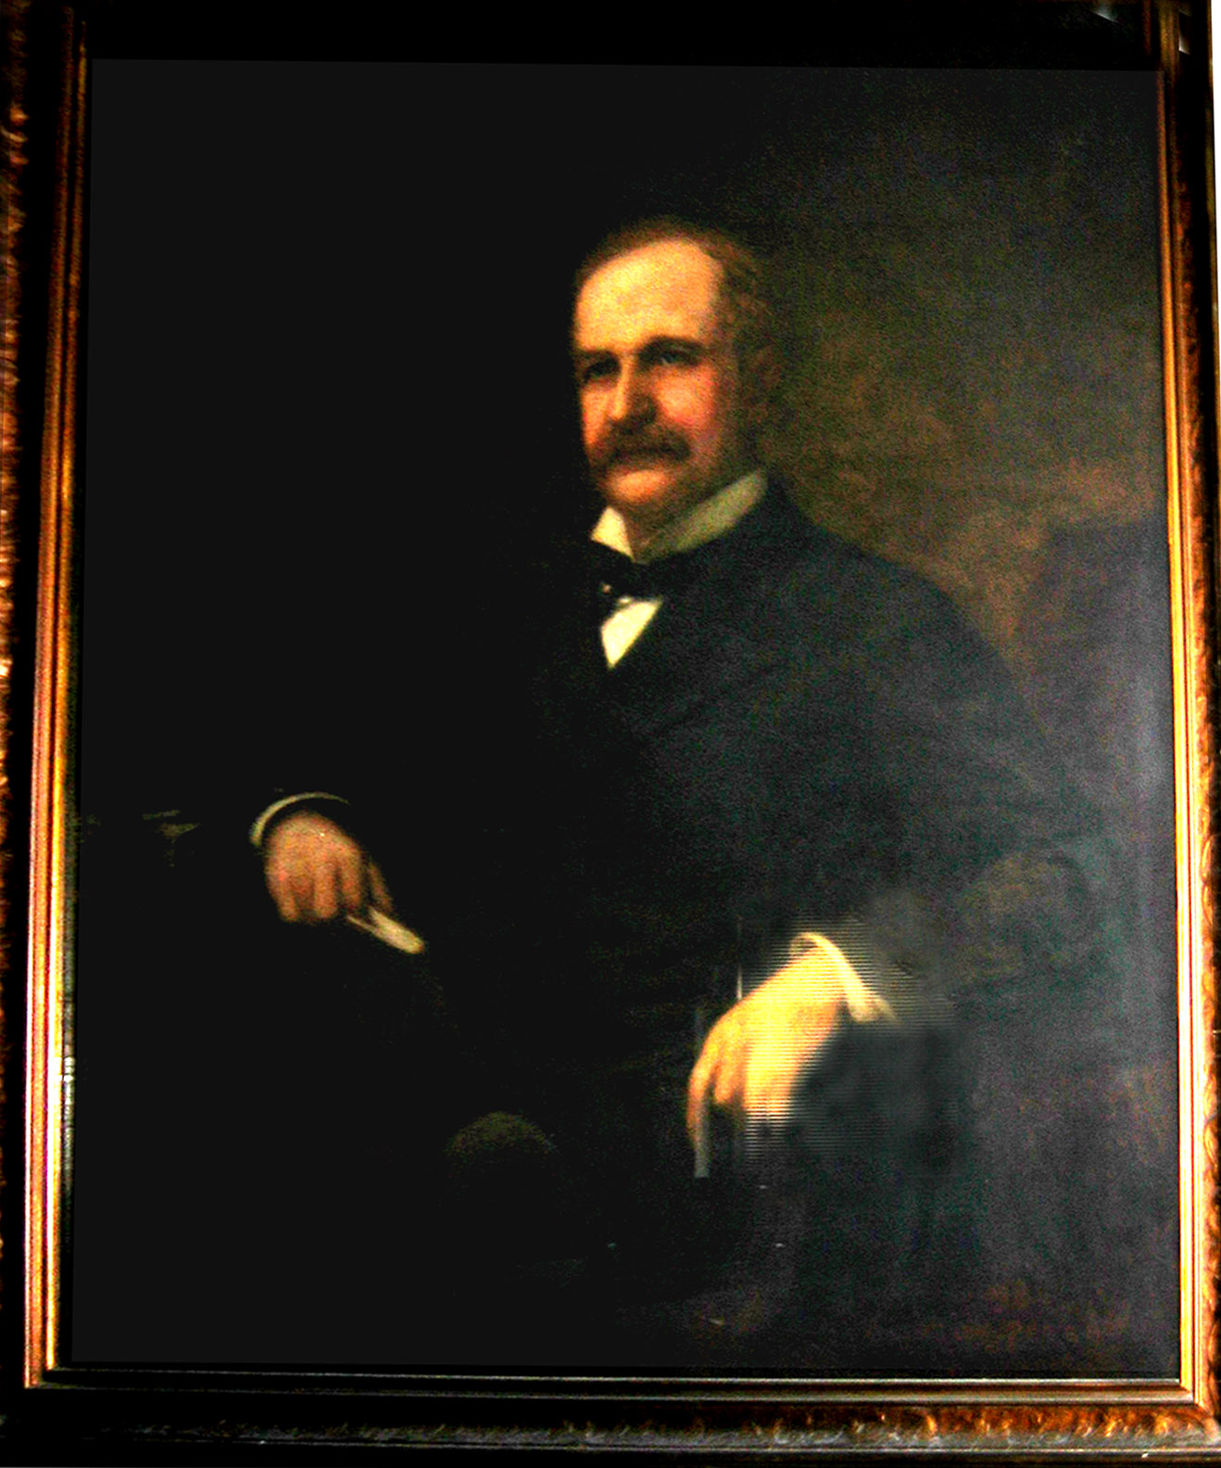

Title/Subject: William A. Fisher (1837-1901) Artist: Clinton Peters (1865-1948)

Date: Late 19th C /Early 20th C. Medium: Oil on canvas

Dimensions: Frame: 48 ½ H x 42 W in.

Signature/Date X Yes No, Location: Lower right

Marks/Labels X Yes No, Location: Bottom center

Description: Plaque reads William A. Fisher, 1882-1887

General Condition:

Painting: Poor Fair / Good X Excellent____

Comments: The painting is in fair to good condition. There is a small scratch on the bottom center of the canvas as well as a “zipper” like raised canvas line extending from the middle of the subject’s torso above to the left end of the canvas.

Frame: Poor____ Fair____ Good X Excellent____

Comments: There is a glazing over the painting. There are a few chips in the frame here and there.

Conservation Priority: Low X Medium / High _____

Comments: Have a conservator consult the piece.

Additional Comments:

Condition Report Work Sheet

Object #_______

Location: East Courthouse

Date of examination: 08-01-2004

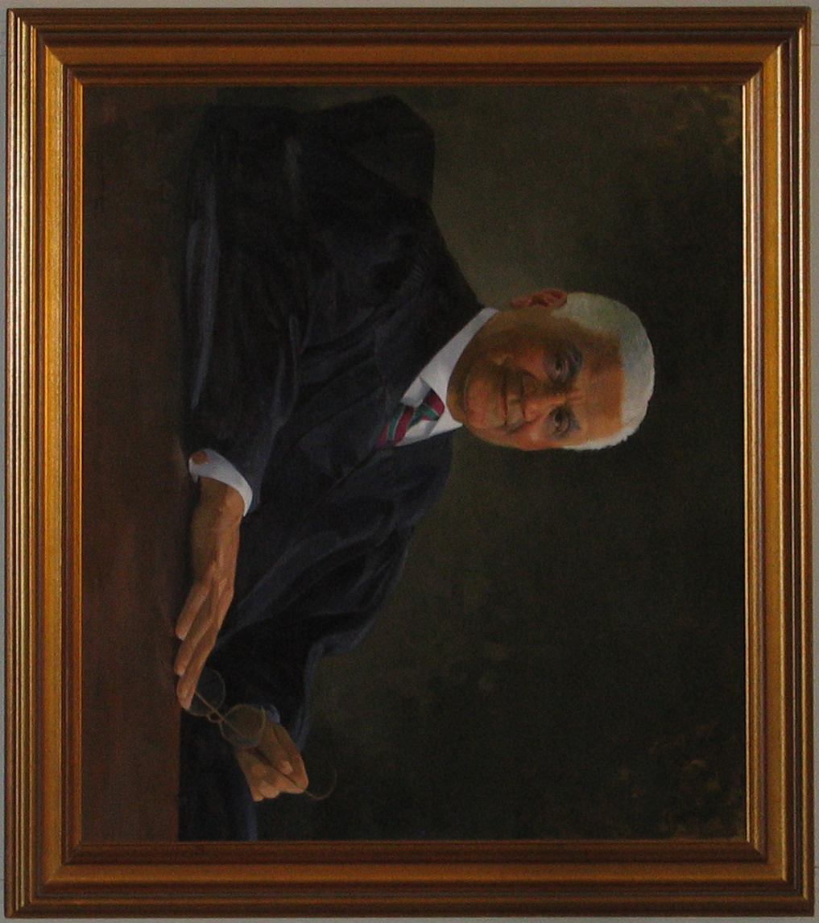

Title/Subject: Joseph C. Howard (1922-2000), Artist: Simmie Knox (1936 ), Date 1992

Dimensions: 57 H x 51 W x D in.

Signature/Date X Yes No, Location: Lower left

Marks/Labels Yes No

Description:

______________________________________________________________________________________

General Condition:

Painting: Poor Fair Good X Excellent__/__

Comments: The painting is in good to excellent condition.

Frame: Poor Fair Good X Excellent__/__

Comments: The frame is in good to excellent condition.

Conservation Priority: Low X Medium High _____

Comments:

Additional Comments:

Condition Report Work Sheet

Object #_______

Location: East Courthouse: Bench Conference Rooms 510

Date of examination: 07-21-2004

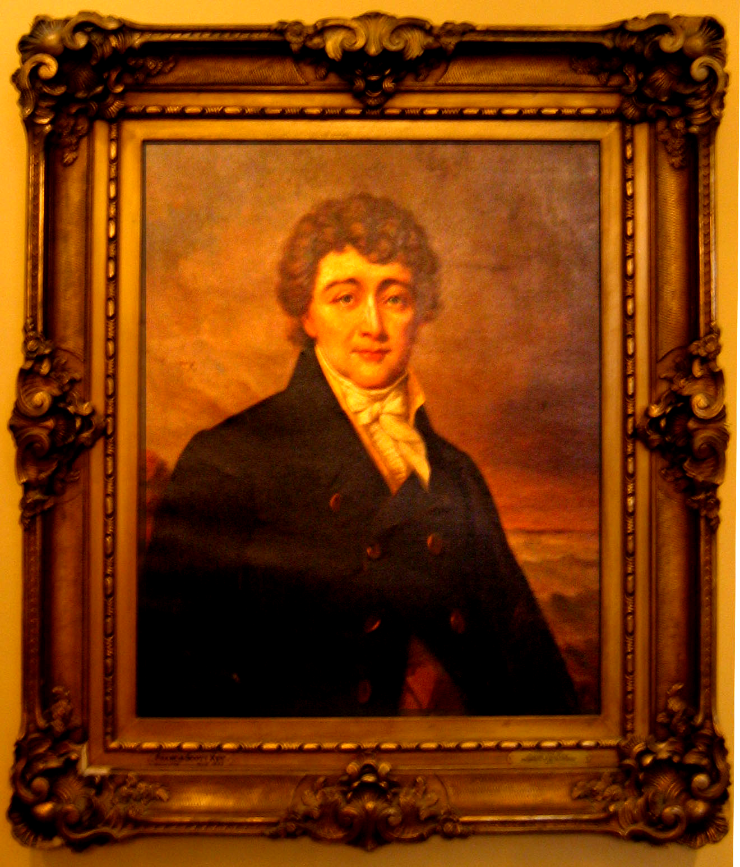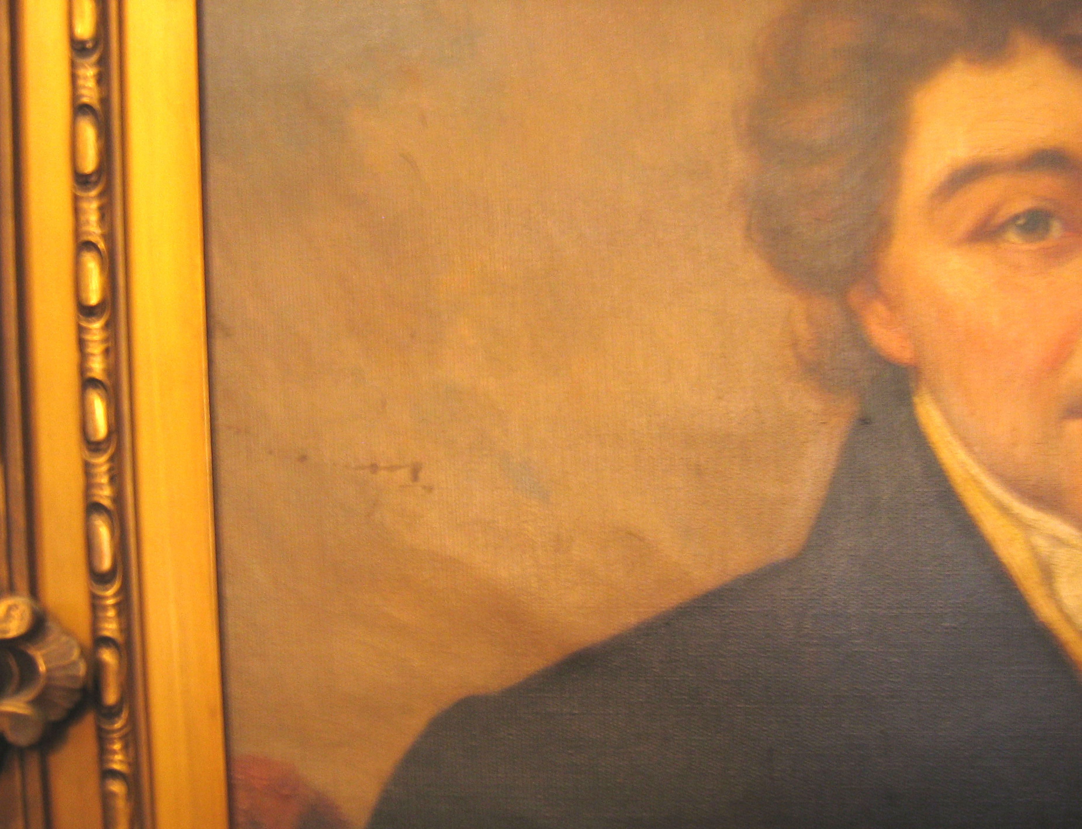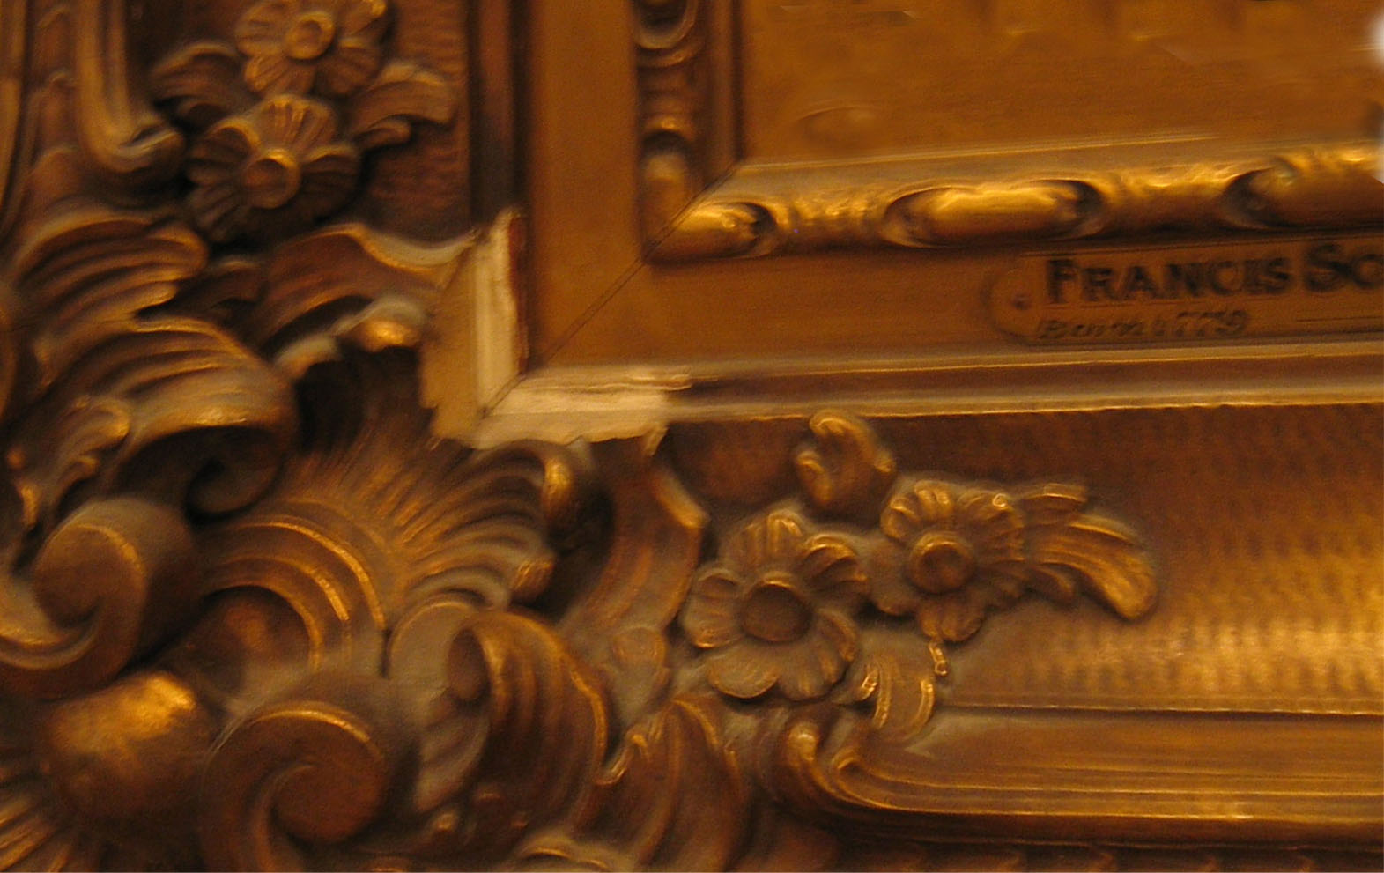

Title/Subject: Francis Scott Key (1779-1843) Artist: Louis P. Dietrich (1841-1922) Date: 1914

Medium: Oil on canvas

Dimensions: Frame: 43 H x 37 W in.

Signature/Date X Yes No, Location: Lower right

Marks/Labels X Yes No, Location: Lower Left & Right

Description: Plaque lower left reads: Francis Scott Key Born 1779-Died 1843, lower right plaque reads Presented by Avalon chapter of the Daughters of the American Revolution 1914
______________________________________________________________________________________

General Condition:

Painting: Poor Fair X Good / Excellent______

Comments: The painting is in fair to good condition, but there appears to be a small tear/visible canvas on the lower left as well as small red spots along the left side.

Frame: Poor Fair X Good Excellent______

Comments: The frame is in fair condition. There are chips throughout the frame, especially in the lower left portion of the frame. The decorative leaf on the outer/inner portion of the frame is broken off.

Conservation Priority: Low X Medium High _____

Comments: Not sure if red spots on the right are intentional, see image above.

Additional Comments:

Condition Report Work Sheet

Object #_______

Location: East Courthouse: Courtroom Family 2

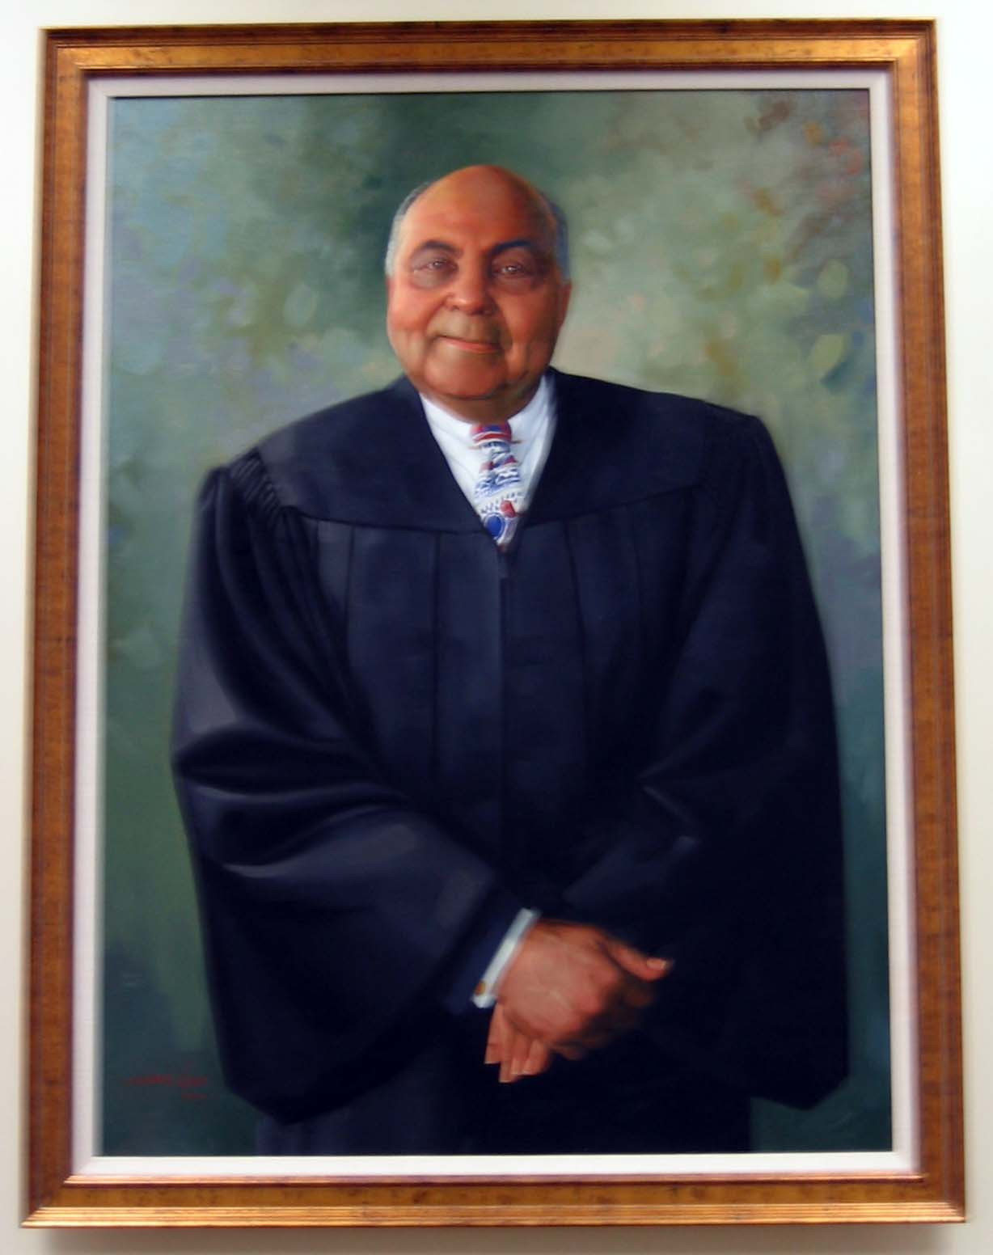

Title/Subject: Robert B. Watts (1922-1998) Artist: Simmie Knox (1936- ) Date: 2001

Medium: Oil on canvas

Dimensions: Frame: 49 H x 37 4/16 W in.

Signature/Date X Yes No, Location: Lower left

Marks/Labels Yes X No, Location:

Description: A standing portrait of subject.

______________________________________________________________________________________

General Condition:

Painting: Poor Fair Good X Excellent__/____

Comments: The painting is in good to excellent condition

Frame: Poor Fair Good X Excellent __/__

Comments: The frame is in good to excellent condition.

Conservation Priority: Low X Medium High _____

Comments: There are no major issues or conservation concerns.

Additional Comments:

