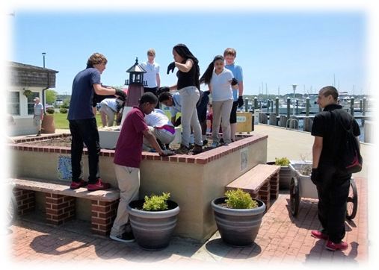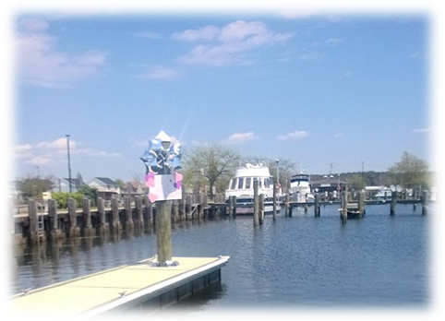

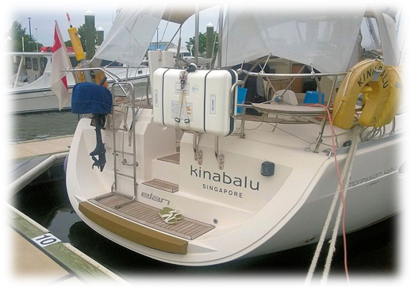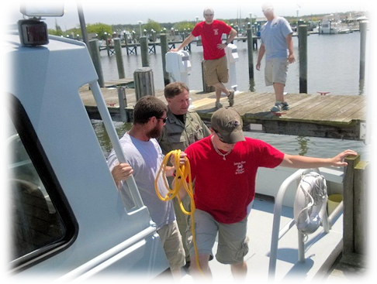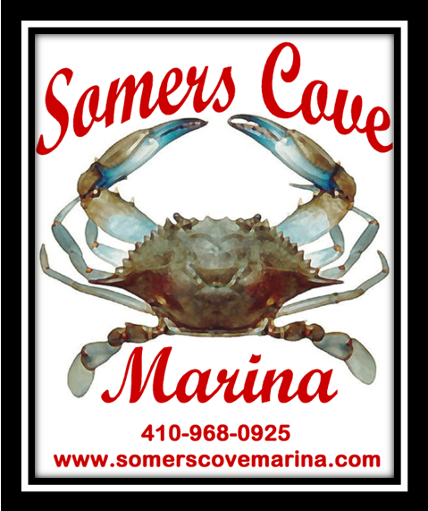
Table of Contents
Annual Report
  - FY 2013
Somers Cove Marina
2014
Visitors from around the world.
Training Day with
help from NRP.
Somers Cove’s first
honeymoon suite
Mr. Long’s 7th grade class lending
a helping hand.

History 2
Marina Information
Location 3
Recent Highlights 4
Strategic Highlights 4
Financial Highlights 5
Operating Highlights 6
Financials
Income 7
Expenses 8
Profits and Losses……………………………………………………………………………………………………………….……..9 & 10
Grants 11
In the Future
Strategies 12 & 13
Repairs……………………………………………………………………………………………………………………………………14 & 15
Contact Information
Marina Commission 16
Marina Personnel 17

Somers Cove Marina was dedicated during a ceremony held on site on June 16, 1962 by the late Governor J. Millard Tawes. Guests were entertained by the U.S. Naval Academy Band while enjoying a crab feast and fireworks. At this time, the marina was governed by five Crisfield Port Commission members and a Marina Manager, Bill Guy. The Commission consisted of three local members, H. Harvey Bradshaw, John S. Catlin and Ira T. Todd, and two members of the Somerset Commission and Maryland Port Authority, E. Layton Riggin and Avery T. Hall. A 26 foot vessel would pay approximately $4.62 per foot for a total of $120.00 in 1962.

In 1966, the Somers Cove Restaurant, Skipjack Lounge and Bug-Eye Bar opened on the North West side of the marina basin. The original boat basin included docks “A”, “B”, “C”, “D”, “E” and the fuel pier “F”, totaling one hundred seventeen (117) slips. Many renovation projects have been completed, resulting in present day Somers Cove Marina comprising approximately one hundred seventy acres with 515 boat slips on 16 piers with water and electric hookups.
In April of 1972, the City of Crisfield and the Somerset County Commissioners constructed bleachers on the marina property for use of public agencies of the County and City. The original bleachers cost $35,500. The Tawes Museum and Visitor Center was built in the marina by 1979 for the sum of $500,000, paid by Waterway Improvement Funds.
1980 brought about much change at Somers Cove. The launching ramps were moved from the “B” pier area across the harbor next to the Coast Guard Station. The Marina Office replaced the Restaurant, Lounge and Bar. Acquisition of more property allowed the construction of docks ”K”, “L” and “M”. Construction of The Charter Boat Facility began in 1989, and included the piers “N”, “O” and “P”. The catwalk or “CW” pier was completed in 2007.
Present day management of Somers Cove Marina was created in January 2009 when the State of Maryland turned over the reins to the new Somers Cove Marina Commission. The Commission, under the direction of the Somers Cove Marina Executive Director, has again made the marina a profitable venture.
With support of our local Senator and Delegates, the Department of Natural Resources, the City of Crisfield and Somerset County Commissioners, Somers Cove Marina continues to compliment the local Crisfield economy.

LOCATION
Somers Cove Marina is located on the Tangier Sound in the Chesapeake Bay at 37° 58.6 North and 75° 51.9 West. Approximately 125 miles south of Annapolis, the marina's address is 715 Broadway, Crisfield. On the Delmarva Peninsula, Crisfield is at the end of Maryland Route 413.
Maryland USA
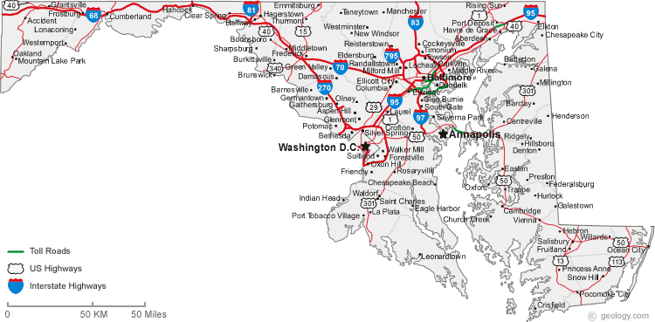
Crisfield is located on the Delmarva Peninsula at the end of Maryland Route 413. From the Wilmington, Philadelphia areas take US Route 13 south to 413, 3 miles south of the Town of Princess Anne. If you are coming from Washington, DC or Baltimore areas take US Route 50 south to Salisbury and then proceed south on US Route 13 to Maryland 413. Crisfield is located 14 miles south of the intersection of 13 & 413. Follow the signs to Somers Cove Marina.
Crisfield
Somers Cove Marina
Delaware

LOCATION
With 515 fixed and floating slips, 7 sets of bath houses, 1 large and 3 small pavilions, swimming pool, picnic areas, a boat ramp, laundry facilities, boat shed and the Crisfield Heritage Foundation on site, Somers Cove Marina is noted as one of the finest marinas on the Chesapeake Bay.
A welcome port of call for all vessels, the marina offers a safe and secluded berth protected on three sides by land. Somers Cove opens as free dockage during storms to all vessels declaring Safe Harbor. Recreational boaters as well as watermen and their families seek shelter in the marina's buildings and slips.

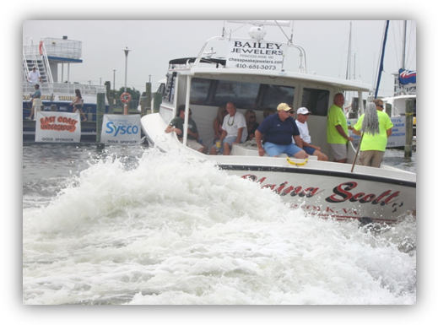RECENT Highlights
Two new festivals have been added to the list of events held at Somers Cove Marina. The 2013 Boat Docking Contest was held at B Pier during the Labor Day weekend and attracted approximately 4,000 additional visitors. This exciting event is a timed competition for the quickest and most skilled mariners.
In September, Dock Day on the Bay was a celebration of the history, heritage and maritime culture of both commercial fishing and sport fishing on the Chesapeake. The daylong event featured in-water working fishing boats, seafood cooking demonstrations, fishing gear demonstrations, safety at sea, a seafood market, live music, children’s activities, a Blessing of the Fleet and much more.
Boat Docking practice for the Elaina Scott.

Strategic Highlights
The Marina has branched out and partnered with the local restaurants and gift shops to provide coupons and discounts to arriving boaters. Most coupons offer $5.00 off of purchases and discounts up to 10% off.
A large number of boaters seem to be selling or dry docking the larger vessels and downsizing to smaller vessels. Once holding a waiting list, Somers Cove now has empty slips. A remedy was to offer smaller vessels a different season, (May – October or June – November) using the same rates that Somers Cove offered as second quarter rentals has proven successful. Several boaters that have given their slips up have heard of the new “deal” and returned as slip holders, purchasing fuel, ice and supplies as well.
Catering to the smaller vessels, two weeks ago the marina cleaned out a vacant fish cleaning building and transformed it into a boat ramp store. Selling necessities such as ice, bait, drinks and snacks, the attendant also takes pictures of the day’s catch and posts them to the internet. While it is still early yet, this is beginning to catch on and anglers from the shore are showing interest in boating the lower bay.
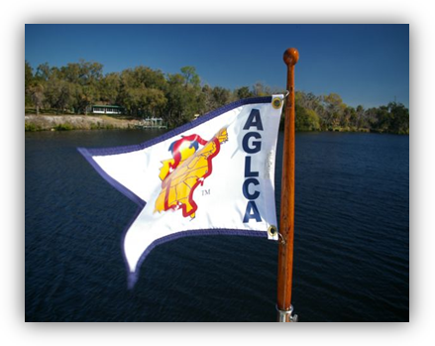Advertising with the America’s Great Loop Cruisers’ Association (“Loopers”) has been fruitful. Many boaters have visited on their way to the Norfolk rendezvous in May and even more returned in June. Advertising on the internet via Marinas.com and the Waterway Guide has helped reach boaters to let them know about the dockage specials the marina is offering. Spin Sheet and Prop Talk magazines are always productive. Listing upcoming events such as the Labor Day festival is planned for the next issues.

Financial Highlights
Cutting back expenses in personnel and supplies has helped little to offset some of the losses in revenue. At the same time, capital improvements have hurt the bottom line. In January 2014, the main office lost electricity to one half of the building. The transformer had blown a leg and the other side was sure to follow. The Commission funds repaired the transformer at a cost of $5,000.
The roofs on all nine buildings had to be repaired. Leaks became evident in the bath houses and the office from the cedar shingles nearing their life expectancy. Seven skylights at the boat ramp and charter center had to be replaced. The Commission funds repaired the roofs at a cost of $15,000.
Marina computers and the server were showing their age. The operating system was no longer going to be warranted by Microsoft for upgrades. The computer system controls the fuel pumps, point of sale and is the center of the marina operation. The Commission chose to upgrade to new computers, server and software at a cost of $17,000.
Full time salaries for the Marina Manager and Maintenance Chief increased $10,400 during FY14. John David Wilson held the position of Maintenance Chief since 1989 and retired June 30, 2014.
Workers Compensation for Commission Employees rose to $25,519 during FY14 due to an accident claim in FY13 by a seasonal employee. This penalty will be removed in FY15 lowering it by $4,000.
Annual slip rentals dropped in FY14. The number one customer reason was, “we cannot afford to keep our boat.” The rise in fuel prices has forced many recreational boaters in our area to sell or dry dock their vessels. Many of the larger vessel owners gave up their slip this year for a loss of $30,000.
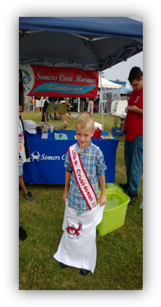Operating Highlights
In July 2013, the Freedom Fest fireworks and festival was moved from the marina. This holiday rate revenue is hard to replace. Boaters chose to go elsewhere for the weekend and it is a struggle to get them to return. In 2014, however, the fireworks are back in the marina. Advertisements have gone out and at least one group has reserved 12 slips. 2015 looks to be a more promising year with the potential for a $20,000 increase in transient income.
The Dock Days on the Bay was a successful event. Visitors came from neighboring states to the marina. While few showed interest in renting annual slips, many commented on the state of the marina and vowed to return as transient guests by towing their vessels by trailer or by cruising in.
Little Mr. Crustacean wins a T-Shirt at the Marina booth at Dock Days on the Bay.
Delmarva Media Group, publishers of local newspapers, awarded the marina the Gold Medal as the 2013 Readers Choice for Best Marina.
A new event in October 2014 is anticipating a large crowd. The Crisfield Hunting and Fishing Expo will be held in the marina on October 11th and will feature Duck Dynasty star John Godwin. The Expo will have a decoy retriever contest, duck calling contest, boats for sale in, Duck Dynasty Competition and much more. This is the perfect opportunity for the marina to advertise and show its best assets for potential customers.
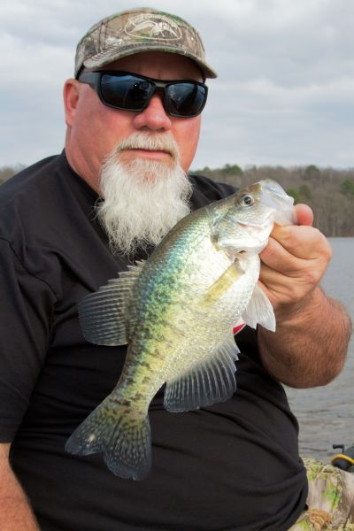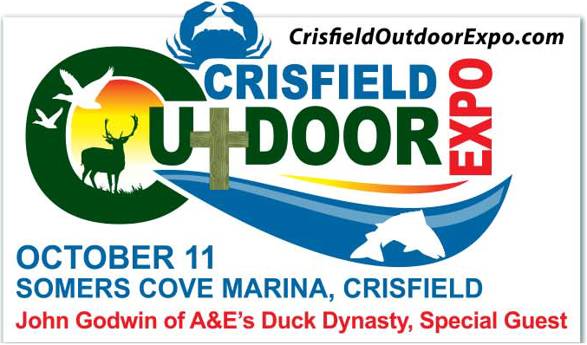
John Godwin of Duck Dynasty

INCOME
The Marina’s annual slip revenue continues to decline. We hope that marketing plans such as a June Shake Down Cruises, eMarketing (Facebook and websites) will an upward trend of transient vessels to Somers Cove.

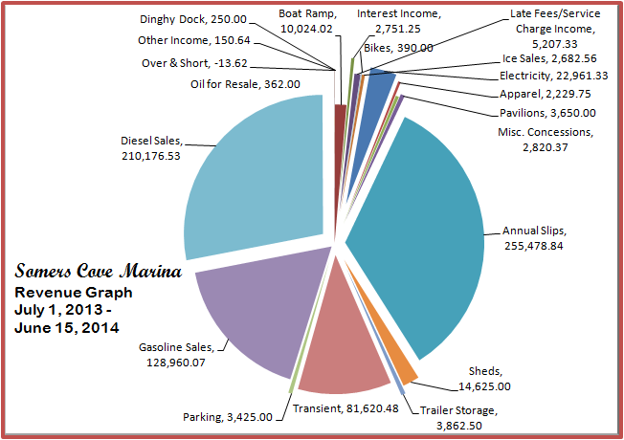

EXPENSES
The graph below illustrates a partial year from July 1, 2013 through June 15, 2014. Vehicles increased by approximately $3,000 due to repairs to marina vehicles in 2013. The increase in Fuel and Utilities is directly related to the City of Crisfield metering the water usage. Even though seasonal labor has decreased $25,000 from FY13, general liability insurance increased to a total of $23,000 to date in FY14.

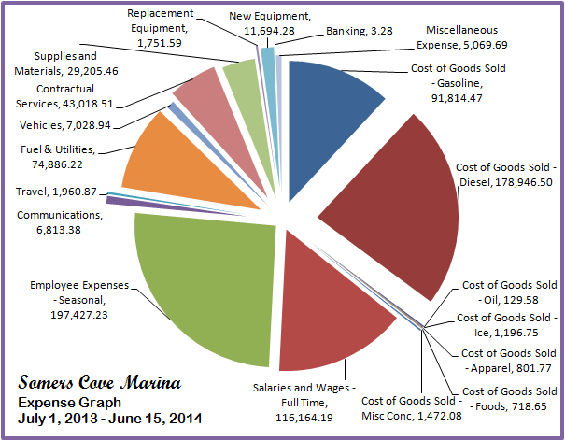

PROFITS AND LOSSES
Income
 |  | Dinghy Dock | 250.00
 |  | Boat Ramp | 10,024.02
 |  | Interest Income | 2,751.25
 |  | Late Fees/Service Charge Income |  | 5,207.33
 |  | Bikes | 390.00
 |  | Ice Sales | 2,682.56
 |  | Electricity | 22,961.33
 |  | Apparel | 2,229.75
 |  | Misc. Concessions | 2,820.37
 |  | Pavilions | 3,650.00
 |  | Annual Slips | 255,478.84
 |  | Sheds | 14,625.00
 |  | Trailer Storage | 3,862.50
 |  | Transient | 81,620.48
 |  | Parking | 3,425.00
 |  | Gasoline Sales | 128,960.07
 |  | Diesel Sales | 210,176.53
 |  | Oil for Resale | 362.00
 |  | Over & Short | -13.62
 |  | Other Income | 150.64
 | Total Marina Revenue |  | $ 751,614.05

Expense
Cost of Goods Sold
 | Gasoline | 91,814.47
 | Diesel | 178,946.50
 | Oil | 129.58
 | Ice | 1,196.75
 | Apparel | 801.77
 | Foods | 718.65
 | Misc Concessions | 1,472.08
Total Cost of Goods Sold |  | 275,079.80
Salaries and Wages - Full Time |  | 116,164.19
Employee Expenses - Seasonal |  | 197,427.23
Communications |  | 6,813.38
Travel |  | 1,960.87
Fuel & Utilities |  | 74,886.22
Vehicles |  | 7,028.94
Contractual Services |  | 43,018.51
Supplies and Materials |  | 29,205.46
Replacement Equipment |  | 1,751.59
New Equipment |  | 11,694.28
Banking |  | 3.28
Bad Debt |  | 5,069.69
 | Total Marina Expense | $ 770,103.44
NET INCOME ($18,495.39)

GRANTS

FY14 BIG Grants
 | Transient Power Pedestals |  | $ 194,300
 | Fire Suppressant System |  |  | $100,000
 | TOTAL | $294,000

WWI Grants
 | 2014 Grant |  | $ 100,000
 | Repairs to Piers, General Repairs
 | TOTAL | $100,000

STRATEGIES
- Marketing - A more aggressive marketing strategy is needed to increase annual slip holders. Local ship yards are spilling over with the larger vessels of past customers of Somers Cove. Assisting with the marketing in of those vessels in metropolitan areas in conjunction with a “deal” at the marina may help refill the empty slips.
- Website – The marina is pursuing a new website that will work more efficiently on cell phones, offer user friendly apps for reservations and stand out more in search engines. This $600 upgrade will take place in FY15.
- Boats for Sale – A ‘bulletin board’ will be added to the web site to post boats for sale at the marina. By promoting the vessels in the marina that are on the market, potential buyers may be interested in the marina as well. Currently boats are being pulled to dry dock or on land and sitting in driveways. This feature will take place in FY15.
- Boater’s Lounge – Transient boaters need a place to get out of the sun and relax. The marina needs to find a place for this to happen. Air conditioning, heating and the weather channel are necessary. This is something to be pursued in the future.
- Shuttle – The new Executive Director should pursue a shuttle service for transient boaters. The marina can work with the City of Crisfield to pass an ordinance to allowing golf carts on city roads. The marina could then purchase carts to rent or purchase a multi-passenger cart (which ever would be bore cost effective). This is something to be pursued in the near future.
- Map – A new map and professional brochure for the marina is a must. It needs to be printed and distributed at all boat shows and shared with other marinas on the east coast. This is something that must be done immediately.
- Signs – The new Executive Director should also look for means to replace the old signs at the marina. The current signs are incorrect, faded and chipping, and are not a good representation of the outstanding marina that we have. This could be a FY15 or FY16 project.
- 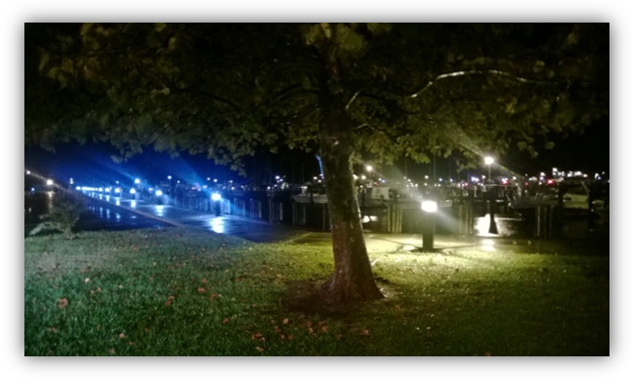Energy – When the marina lost its electrician, it was no longer able to transform the old lighting to energy saving bulbs. This project needs to be continued. Currently, the marina is looking at trying new lighting in J Pier bath house. This upgrade will occur sometime in FY15.
New energy efficient lighting in place at Somers Cove.

REPAIRS IN FY15
A Pier - A Pier will be under repair for structural damage caused by wear and tear of time. Its age and use by large cruise vessels has left it with decayed stringers and cross braces. Face boards or wave boards were destroyed by previous storms and years of wear. This project will be funded by Waterway Improvement Grants in FY 15. Projected cost - $65,000

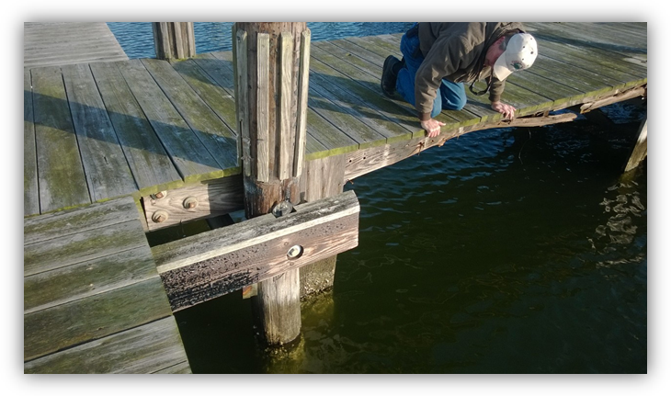

Main Office - Transformers from A Pier to J Pier (with the exception of the main office and B Pier) have been replaced. The main office transformer has shown its age by failing this winter. It was repaired with Commission funds in January 2014. It was estimated to have a life expectancy of a “few years.” Funding should be sought to replace this transformer before another issue arises. The new computer system, newly remodeled building, office personnel, pool and transient traffic depend on this transformer. It would be sensible to consider replacing B Pier transformer at the same time. It is approximately the same age as the office and other replaced transformers. Projected expense - $10,000
Electrical - The main electrical cable coming from the outside road to the marina, and running to each transformer on the office side of the marina needs to be replaced. It is estimated to be over 30 years old. As the transformers were replaced, it was evident that this cable was in disrepair and was nearing its life expectancy. When the main electrical cable no longer is in working condition, the marina will be out of power for days, possibly weeks, until repairs can be made. Projected expense - $40,000
Roofs - In FY 14, the roofs of the 9 marina buildings were repaired with cedar single hip and ridge to match the existing roofs. The roof surfaces were given a life expectancy of 1 – 3 years. The marina needs to evaluate the cost effectiveness and the longevity of cedar, asphalt and metal roofs. When a decision is made, the buildings and the pavilions need to be stripped and replaced. We hope our FY15 $100,000 Waterway Improvement Grant will cover this projected cost.
Sink Hole – On June 1, 2014, an approximate 26” x 18” hole appeared in the asphalt parking lot in the area of the South gate storm drain. It was approximately 4’ deep and had an underground radius of about 5’. The hole is growing larger in diameter and one end is hard to tell the exact depth. DNR Boating Services, Engineering & Construction and marina personnel are currently working with the City of Crisfield to find a solution. The estimate to excavate and determine the extent of the problem is $5,000. Repair costs could exceed $50,000
Fuel Pier - The fuel pier has electrical and communication junction boxes located under the pier. Tide and condensation have caused damage to the wires and splices in these boxes. (see below) Recently, new equipment has been damaged and the marina continues to lose communication to the pumps frequently. The boxes need to be removed, new wire run to the pumps and pier, and the boxes need to be located in a safer, dryer environment. This approximate $10,000 expense will be funded by Waterway Improvement Grant Funds in FY15.
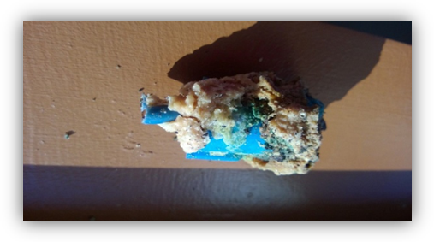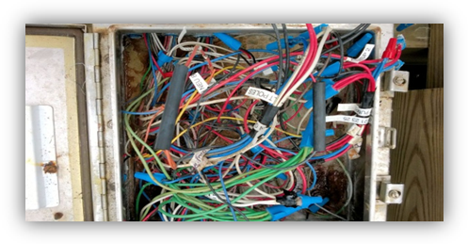
Fuel pier electrical box damage.
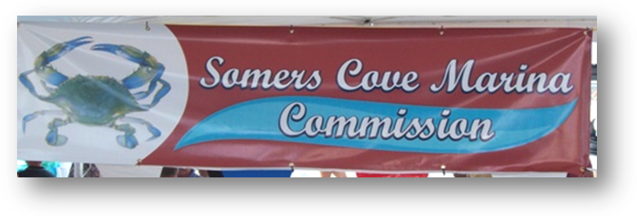
Somers Cove Marina Commission
Name |  | Appointed By |  | Expiration Date
John Anderson |  | Dept. of Natural Resources |  | 12/31/15
**Dr. Michael Atkins |  | City of Crisfield |  | 12/31/16
Ladell Dorman |  | Som. Co. Commissioners |  | 12/31/14
Michael Grant |  | Dept. of Natural Resources |  | 12/31/16
**Leslie Hardy |  | Dept. of Natural Resources |  | 12/31/14
OPEN |  | City of Crisfield |  | 12/31/14
Keith Ward |  | Som. Co. Commissioners |  | 12/31/16
*Dr. Michael Atkins serves as President
**Leslie Hardy serves as Vice President
*As noted above, terms of three Commissioners expire at the end of 2014. DNR, City of Crisfield and Somerset County Commissioners will need to identify new nominees in the fall of 2014.

Mary Taylor  Marina Manager |  | Bonnie Matthews  Admin Assistant |  | Dean Bozman  Certified Plumber
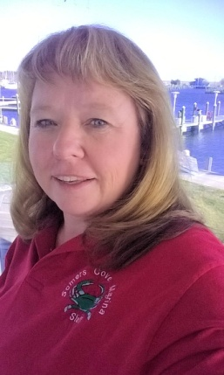 |  | 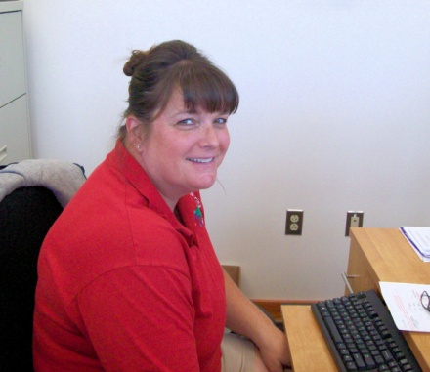 |  | 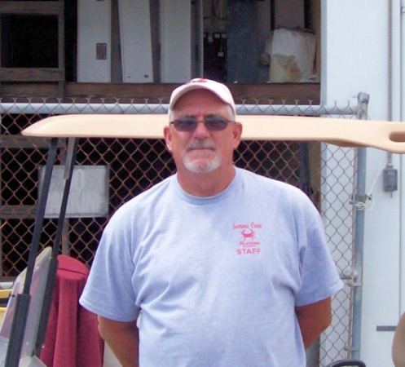
Tel 443-235-0892  mtaylor@somerscovemarina.com |  | Tel 410-968-0925  bmatthews@somerscovemarina.com |  | Tel 410-968-0925

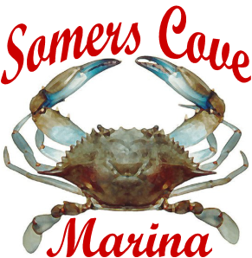

715 Broadway
Crisfield, MD 21817
Tel 410-968-0925
Fax 410-968-1408
www.somerscovemarina.com

