FOUNDATION FUNDING IN MARYLAND

The Governor’s Grants Office (GGO) works closelywith foundations, non-profits, and local governments. All three constituencies use GGO’s website, Annual Report, and participate in our training sessions. On occasion, a State agency will receive a grant directly from a private foundation. A more typical interaction will find a state agency and a foundation working together around a shared goal, with the foundation funding a non-profit organization that is trying to achieve that goal. Many small and medium-size foundations benefit from the technical and performance-based expertise that state agencies can provide. This kind of assistance can help foundations make targeted decisions related to their grant-making goals.

A foundation is a non-governmental, non-profit organization established under the U.S. Internal Revenue Code to support religious, charitable, and/or educational activities. Some foundations are created by individuals or by families, thus they are private organizations. Community foundations are public charities established to serve the needs of a particular geographic area. They provide a framework for individual donors to support charitable causes without having to create their own foundations. Private foundations must distribute at least 5% of their assets each year. Community foundations do not have this same requirement. Some corporations also have their own foundations.

- In Maryland there are 1,409 foundations (2010) according to the Association of Baltimore Area Grantmakers (ABAG).

- Maryland foundation total assets (2010): $11.8 billion.

- In 2009, Maryland foundations gave away a total of $831.6 million, a decrease from $879.5 million in 2008.

- In Maryland, 40% of assets are held by just 2 Maryland foundations - The Annie E. Casey Foundation and TheHarry & Jeanette Weinberg Foundation.
There are thirteen community foundations in Maryland ($399 million in assets) making $46 million in contributions in 2007 (most recent data available). For more information, visit Maryland Community Foundations Association online.

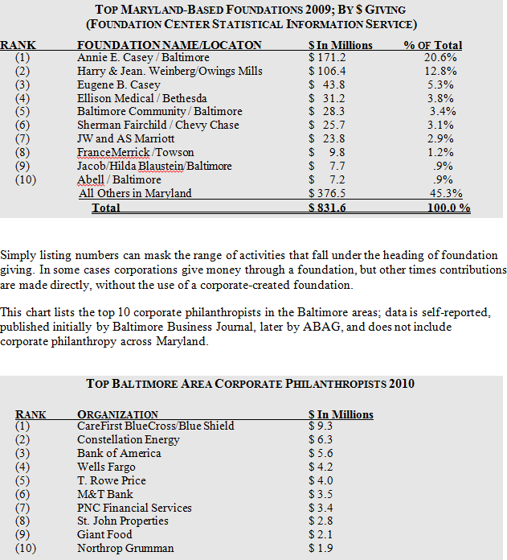

Number of Maryland-Based Foundations By County

Number of Maryland-Based Foundations By County

Montgomery 620 | Frederick 34 | Worcester 15 | Queen Anne’s 9
Balt City 348 | Harford 30 | Carroll 14 | Garrett 8
Balt County 335 | Talbot 26 | St. Mary’s 13 | Cecil 8
Anne Arund 129 | Washington 22 | Calvert 12 | Dorchester 7
Howard 83 | Charles 17 | Wicomico 10 | Caroline 1
Pr. George’s 80 | Kent 17 | Allegany 10 | Somerset 0

NOTE:

The foundations based in each County (total of1,848)were compiled using current data from the Urban Institute’s Center on Charitable Statistic. The figure in the above table totals more than the Association of Baltimore Area Grantmakers’ (ABAG) latest (2010) figure of 1,438total foundations, due to inactive foundations still filing tax forms.

